**Spelling corrections**

**Write these sentences in your jotter or on paper and correct the spelling (incorrect spelling has been circled for you). Remember Perfect Presentation!**

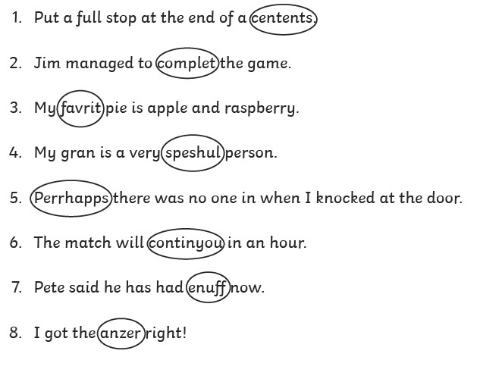

**For this section, you have to write the sentences, correcting the spelling mistake in each one.**

