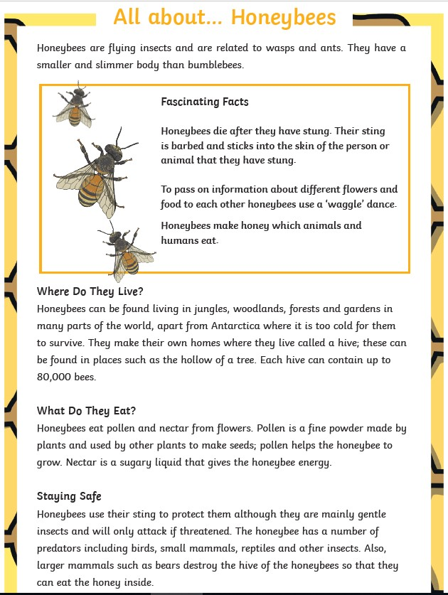

Questions

1. What is the difference between the bumblebee and the honeybee?

1. Where in the world do honeybees NOT live?  Why?
2. Where do honeybees live?
3. How many honeybees can fit into a hive?
4. What do they eat?
5. Who is a honeybees predator?
6. Write at least one fact about honeybees. What have you learned about bees?  You could make a poster to share all that information.