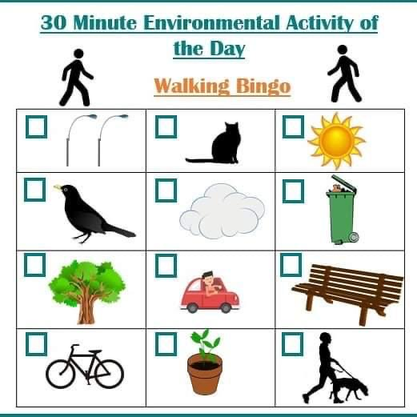Now that we can go out to exercise twice a week, why not try this game of Bingo with your families. Remember to stay safe and maintain the 2 metre social distancing guidance. Have fun!