**Middle Area**

**Some holiday weekend suggestions**

 

Monday 4th May – holiday

Tuesday 5th May – holiday (in Service Day)

Enjoy some time outdoors. Maybe you could try this Rainbow Scavenger Hunt?

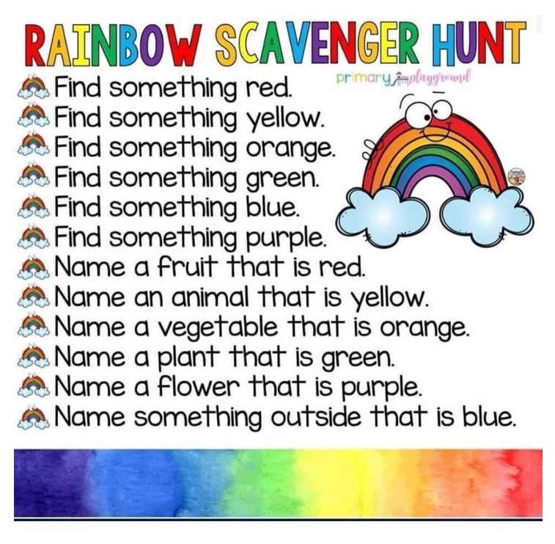

* Make a poster to put in your window. Use a positive and inspirational quote. You can make one up or you can use a Google search to find one you like.
* Make an A-Z list of things that make you happy. Sing along to this (it will make you smile) : <https://www.youtube.com/watch?v=y6Sxv-sUYtM>
* Take a selfie and write down five things you like about yourself. ☺

Why don’t you join in with the Fischy Music Assembly? <https://www.youtube.com/watch?v=BsXqK64r01c>

*Jump Start Jonny is great fun too* [*https://www.youtube.com/watch?v=EbTV9Cew74Q*](https://www.youtube.com/watch?v=EbTV9Cew74Q)

This is a good website for art ideas and inspiration - <http://www.robbiddulph.com/draw-with-rob>

Or, get creative with items in your blue recycling bin – what can you make? Here are some ideas…

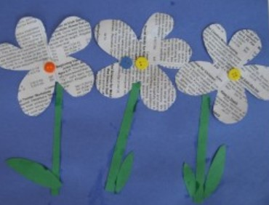 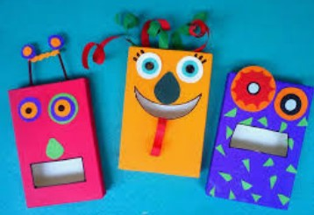 

May the Fourth Be With You – it’s Star Wars Day on Monday! Maybe you’d like to do something to celebrate this special day?!

<https://www.starwars.com/news/5-ways-to-celebrate-star-wars-day-at-home>

<https://www.starwars.com/star-wars-day>



Mrs Marshall retires today and we all know how good she is at promoting our school values. This song is all about Kindness and what a difference we can make when we brighten someone’s day. Sing along and think about Mrs Marshall and the wonderful contributions she made to our school…

<https://youtu.be/iGUABWgeA1Q>

On your own, or with your family members, make a list of the little acts of kindness that you can do to brighten someone’s day at home, such as checking if they are okay, asking if there is anything you can do to help, offering to do something to cheer them up or help them, tidying up without being asked or reminded. How many ideas can ou come up with? How many can you do in a day?



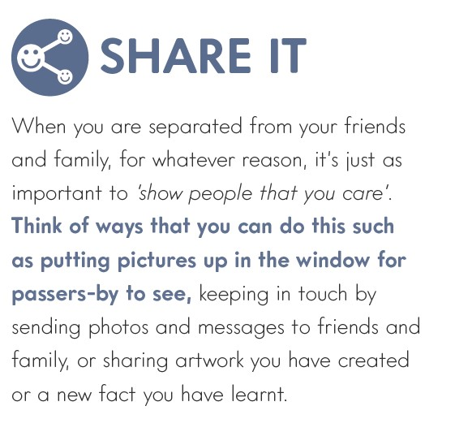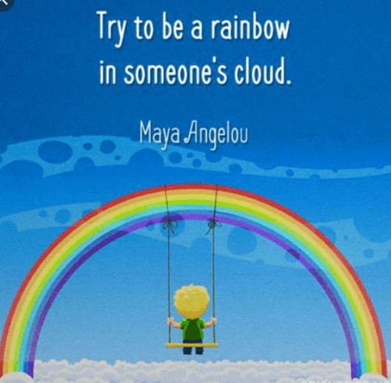

**Have a great long weekend boys and girls – stay safe and take care! We miss you all ☺**

