Marvellous Minibeasts
Activity Grid – Primary 3
Here is a selection of activities for you to carry out at home. There is no order to complete them, and you do not have to do them all. Once you’ve completed the activity, colour the square or give it a tick to show your progess. Please remember to share with Miss Sandy and Miss Cowan what you are achieving – It makes us smile!
Retell your Bug Hunt  Go on a ‘bug hunt’ in your garden.  How many different Minibeasts can  you find? Write some descriptive  sentences about the Minibeasts.  Try to use at least one adjective (describing word) in every sentence and try to put a verb (doing word) and an adverb ( usually ends in ‘ly’ describes the doing word ) in your sentence too.  E.g. The beautiful blue butterfly  fluttered quickly around the small  garden. | Hungry Caterpillar  Everyone knows the story of The Very Hungry Caterpillar by Eric Carle.  If you have forgotten then click on the link:  https://www.youtube.com/watch?v=75NQK-Sm1YY  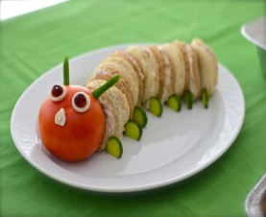 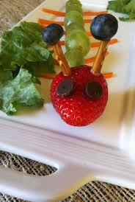  Make a snack which looks like a  Hungry Caterpillar! | Minibeast Hotel  You know that Minibeasts live in Microhabitats. Apply this knowledge to make a cosy home fit for a worm or even a woodlouse!  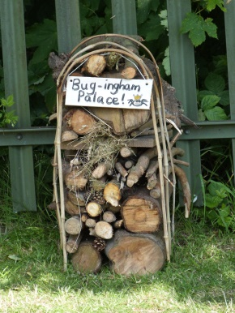  This example is called  Bug-ingham Palace!
Creativity  Create your own Minibeast pets using items around the house. Make it look as realistic as possible. How many legs and wings should it have?  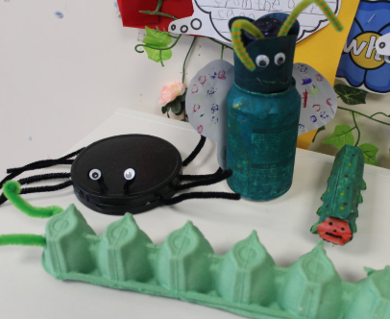 | Minibeast Game  You will need: a dice ( or pieces of paper with the numbers 1 -6) a pencil and paper.  Allocate each body part a number: head = 6, body = 5, leg = 4, antennae = 3, eye = 2, mouth = 1. Take it in turns to throw the dice and collect the part of the body that corresponds to the number. The winner is the person who builds the minibeast first.  You might decide the winner must have an insect with 6 legs and two antenna, a body and head along with 2 eyes and a mouth. | Writing  Write a letter to someone you know who doesn’t like spiders. This could be your teacher or friend and explain why they shouldn’t be scared of spiders. You can persuade them by using powerful language like ‘I feel’ or ‘I believe’ .  Look for information online and in non-fiction books to support your ideas.  You will be able to share your letter with them when we are back in school together.
Centipedes and Centimeters  What do you they have in common?  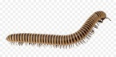  Cent  Cent means 100  There are  100centimeters (cm) in 1 meter (m).  Measure 10 items around the house using centimeters. Can you find an object which is exactly 100cm? | Alphabetical Minibeasts  Can you think of a Minibeast for each letter of the alphabet  A – Ant  B – Butterfly  C….. | Art & Design  Draw, paint or make models of a new Minibeast.  Then give them a name and describe their special features.  They could have 3 bodies and 5 wings…

