

**KPS ECO HEROES**

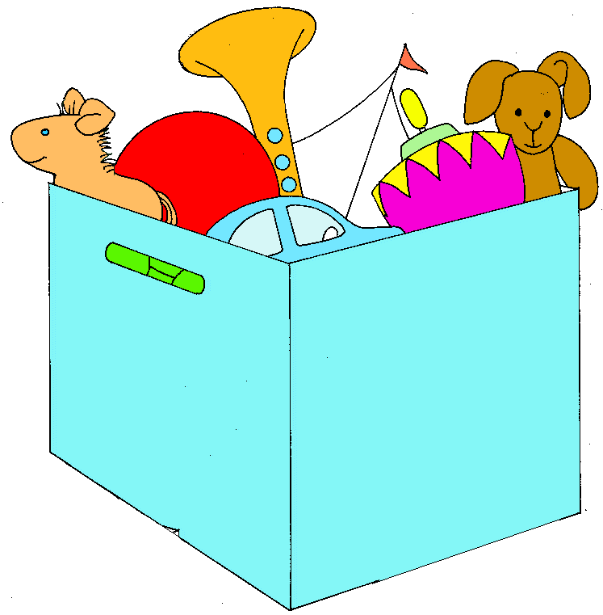**Complete these challenges and be an ECO hero!**

**Turn off your light, TV and devices when you are not using them to save energy.**

**Sort through your clothes and toys. Make a bag to donate to charity (when it is safe).**

**Be a waste warrior!**

**Try to finish all of your meals.**



**Turn off the tap while you are brushing your teeth to save water.**

**Plant something in your garden. You could plant a seed to grow flowers or your own food. Nurture it and watch it grow.**

**Do an activity that doesn’t need electricity e.g. read or draw**







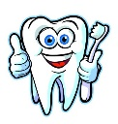



**Please continue to reduce, reuse and recycle at home. Make sure you put your rubbish in the correct bin.**

**Get crafting using recycled materials (see the link in the blog post for ideas).**