Magic Squares
In a Magic Square, every row, column and diagonal all add up to make the same total.
In a traditional 3 by 3 magic square, the digits 1 to 9 are used to make totals of 15, like the one below. Each digit can only be used once.

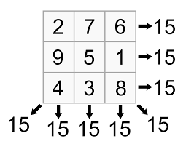

However, other totals can be used and larger grids – for example 4 by 4 or 5 by 5.

Below are some different magic squares. See if you can complete them!

 | 8 |  | 1 |  |  |  |  |  |  |  | 9 |  | 2
 |  |  | 5 |  | 7
 | 4 |  |  |  | 2 |  |  |  | 8
8 |  |  |  |  |  |  |  | 4
1 |  | 5 |  |  |  |  |  |  |  | 5 |  | 7
 |  | 7 |  |  |  |  |  |  |  | 1

For these puzzles use the numbers 1-16 to complete the puzzle. Your rows, columns and diagonals should add to 34.
 | 11 |  | 5 |  | 7 |  | 9
6 | 13 | 12 |  |  |  | 11 |  | 16
 |  | 7 |  |  |  | 6
15 |  |  | 10 |  |  | 13 | 8 | 1

Can you come up with your own magic square for us to solve?

