Early Pupil Friendly Reading Targets- Understanding, Evaluating and Analysing
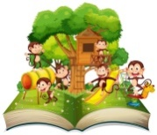  I can use pictures to help me understand words in books | 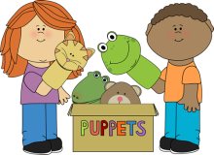  I can ask and answer questions about my book | I can retell the story through role-play | 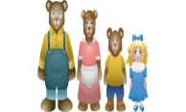  I can talk about what happens to the characters in the story | I can predict what will happen next | 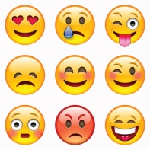  I can talk about how this book made me feel

I can use pictures to help me understand words in books | I can ask and answer questions about my book | I can retell the story through role-play | I can talk about what happens to the characters in the story | I can predict what will happen next | I can talk about how this book made me feel

I can use pictures to help me understand words in books | I can ask and answer questions about my book | I can retell the story through role-play | I can talk about what happens to the characters in the story | I can predict what will happen next | I can talk about how this book made me feel

I can use pictures to help me understand words in books | I can ask and answer questions about my book | I can retell the story through role-play | I can talk about what happens to the characters in the story | I can predict what will happen next | I can talk about how this book made me feel

I can use pictures to help me understand words in books | I can ask and answer questions about my book | I can retell the story through role-play | I can talk about what happens to the characters in the story | I can predict what will happen next | I can talk about how this book made me feel

