Early Pupil Friendly Reading Targets- Tools for Reading
I can read from left to right and turn pages correctly | 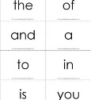  I can read some tricky words | cat  I can use picture clues to help tell the story | 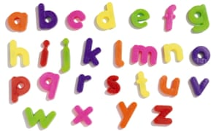  I can recognise and read different sounds | I can slide sounds together to read a word | 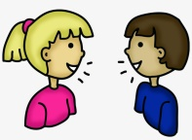  I can tell someone what happened in my story

I can read from left to right and turn pages correctly | I can read some tricky words | cat  I can use picture clues to help tell the story | I can recognise and read different sounds | I can slide sounds together to read a word | I can tell someone what happened in my story

I can read from left to right and turn pages correctly | I can read some tricky words | cat  I can use picture clues to help tell the story | I can recognise and read different sounds | I can slide sounds together to read a word | I can tell someone what happened in my story

I can read from left to right and turn pages correctly | I can read some tricky words | cat  I can use picture clues to help tell the story | I can recognise and read different sounds | I can slide sounds together to read a word | I can tell someone what happened in my story

I can read from left to right and turn pages correctly | I can read some tricky words | cat  I can use picture clues to help tell the story | I can recognise and read different sounds | I can slide sounds together to read a word | I can tell someone what happened in my story

