Early Pupil Friendly Reading Targets- Finding and Using Information
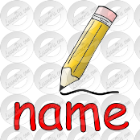  I can read my own name | 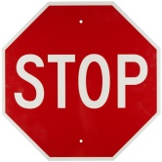  I can read words in and outside school | 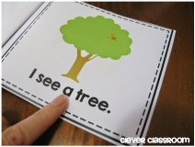  I can find words in a book | 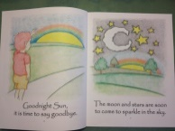  I can use page numbers to find information | I can make links with what I read and what I already know

I can read my own name | I can read words in and outside school | I can find words in a book | I can use page numbers to find information | I can make links with what I read and what I already know

I can read my own name | I can read words in and outside school | I can find words in a book | I can use page numbers to find information | I can make links with what I read and what I already know

I can read my own name | I can read words in and outside school | I can find words in a book | I can use page numbers to find information | I can make links with what I read and what I already know

I can read my own name | I can read words in school and outside | I can find words in a book | I can use page numbers to find information | I can make links with what I read and what I already know

