Early Pupil Friendly Reading Targets- Enjoyment and Choice
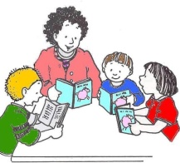  I can read with my group and follow others read. I can listen to others read | 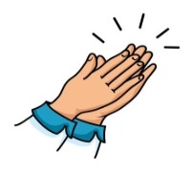  I can clap the rhythm in words | 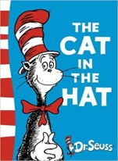  I can say rhyming words | 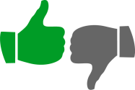  I can say if I like or dislike a story and why | 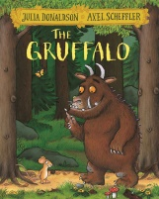  I can choose a story to read. I can talk about the cover, title, author and illustrator | 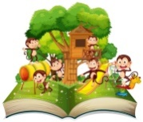  I can use pictures to help me tell the story | 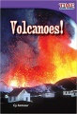  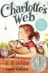  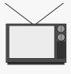  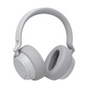  I can say what type of writing this is, fiction or non-fiction

I can read with my group and follow others read. I can listen to others read | 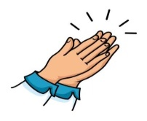  I can clap the rhythm in words | I can say rhyming words | I can say if I like or dislike a story and why | I can choose a story to read. I can talk about the cover, title, author and illustrator | I can use pictures to help me tell the story | 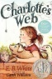  I can say what type of writing this is, fiction or non-fiction

I can read with my group and follow others read. I can listen to others read | 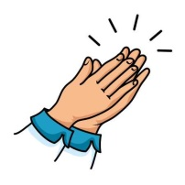  I can clap the rhythm in words | I can say rhyming words | I can say if I like or dislike a story and why | I can choose a story to read. I can talk about the cover, title, author and illustrator | I can use pictures to help me tell the story | I can say what type of writing this is, fiction or non-fiction

I can read with my group and follow others read. I can listen to others read | 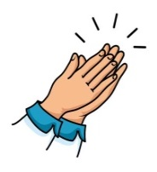  I can clap the rhythm in words | I can say rhyming words | I can say if I like or dislike a story and why | I can choose a story to read. I can talk about the cover, title, author and illustrator | I can use pictures to help me tell the story | I can say what type of writing this is, fiction or non-fiction

I can read with my group and follow others read. I can listen to others read | 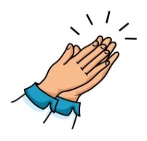  I can clap the rhythm in words | I can say rhyming words | I can say if I like or dislike a story and why | I can choose a story to read. I can talk about the cover, title, author and illustrator | I can use pictures to help me tell the story | I can say what type of writing this is, fiction or non-fiction

