Ladywell NS two’s Home Learning
Week Beginning 8th February 2021
Planned weekly activities for home learning 2021
Hello everyone!
We hope you are all well! We are missing you all in the nursery. Please keep sharing all the exploring and activities you are doing at home with your family, the nursery team are enjoying seeing it all on the Learning Journals. This week we will be sharing some songs, and fun, creative activities for you to do with your family. Please let us know and share with us how you get on with the activities by sharing pictures or videos on your learner’s journals. We look forward to seeing them!
Aimee, Lubica and the Nursery Team.

Day |  | Experience / activity | Children’s feedback
Monday | If your happy and you know it  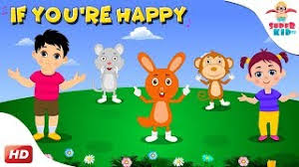  https://www.youtube.com/watch?v=_yYBRqt1xU0&list=RD_yYBRqt1xU0&start_radio=1 | What to do:  *Try to sing the song ‘If you’re happy and you know it.  *Can you do the actions alongside your singing?  *What action was first, second and third? | Ask an adult to take a picture of you singing.  Let us know if you liked the song.
Tuesday | Bottle Shaker  What you need:  *3 empty plastic bottles with a screw top  *rice  *dry beans  *oats  *funnel and spoon  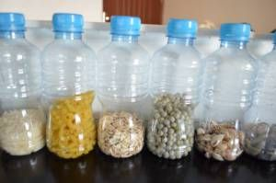  (if you don’t have a funnel you can roll up paper into a cone) | What to do:  Place the funnel in the neck of the bottle and pour in 3 or 4 spoon full of dry rice. Into second bottle, lentils and into third one, beans.  Screw the lid on tightly, start shaking and listen.  *Which shaker is loudest?  *Which one is quiet?  *Can you shake it fast?  *Can you shake it slow?  Extension:  Can you shake your shaker while singing the song: ‘If you’re happy and you know it’ ? | Ask an adult to take a picture of how you make a shaker and share it on your Learning Journal.
Wednesday | Shape monsters  https://www.topmarks.co.uk/early-years/shape-monsters  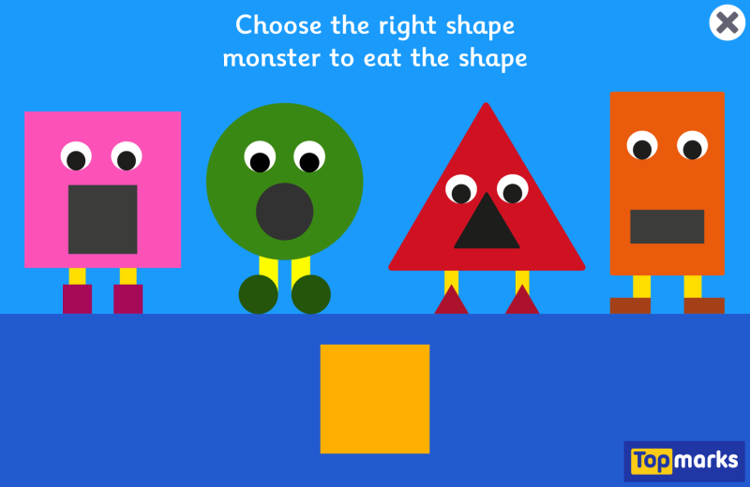 | What to do:  Can you sort the shapes into the correct shape monster?  Extension:  Can you draw any shapes? You could try to draw any shape you like, maybe a circle or a square? | Get an adult to take a picture of you playing the game.  We would love to see your drawings of the shapes you draw on your Learning Journal!
Thursday | 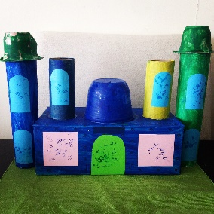  Junk modelling | What to do:  Can you make something from the junk that would go into the recycling bin?  You can paint it, colour it with pencils anything you like to create your own model.  You can use any junk that would go into the recycling bin including toilet/kitchen rolls, yogurt pots, cereal boxes etc | Get an adult to take a picture of your creation, we would love to see what you created on your Learning Journal!

