Ladywell NS 2’s Home Learning
Week Beginning 1st February 2021
Planned weekly activities for home learning Wk beginning 1.2.21
Hello everyone!
We hope you are all safe and well. This week we will be sharing a song and some fun activities for you to try with your family at home. Please let us know how you get on with the activities by sharing pictures or videos on your Learning Journals. We look forward to seeing them!
Aimee, Lubica and the Nursery Team.

Day |  | Experience / activity | Children’s feedback
Monday | Bread making  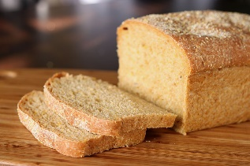  https://www.cookingwithmykids.co.uk/easy-bread-recipe-for-kids/ | What to do:  Can you follow this recipe to make some yummy bread!  You will need an adult to help you!  Extension:  If you have another recipe or anything else you would like to bake that’s great. | Get an adult to take a picture of you whilst you are making your bread and once you’ve finished. You can put it on your Learning Journal for all the staff to see!
Tuesday | Shake our sillies out!  https://www.youtube.com/watch?v=NwT5oX_mqS0 | What to do:  Can you sing and follow to actions to ‘shake your sillies out’?  Singing and dancing can make us feel happy. It allows us to burn off energy and it’s very fun!  Enjoy shaking your sillies out everyone! | Please share a video or picture of you shaking your sillies out, we would love to see it!
Wednesday | Finger painting  What you need:  *2 different colours of paint of your choice  *aluminium foil  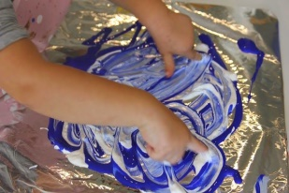 | What to do:  Cover your whole table or just a part of it if possible with aluminium foil, sellotape it on the side to make sure it won’t move while painting on it.  Make different marks with your fingers on the aluminium foil surface and talk about what you did such as zig- zag, spot, circle, square etc.  Extension:  You can recite a rhyme while doing the actions such as: Round and round the garden (you can paint a circle while saying round)  etc. | Get an adult to take a picture of how you paint and share it on your Learning Journal.
Thursday | Make your very own snow at home  What you need:  *Cornflour  *Any cheap hair conditioner  *Bowl/ baking tray to keep the snow in one place  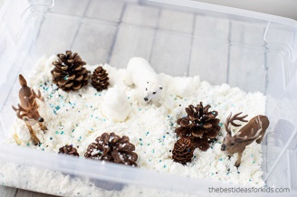 | What to do:  Mix all ingredients and talk about what you feel or what you can make from it. This snow also can have a nice smell from the hair conditioner.  *Is it cold like real snow?  *Can you roll a ball like from real snow?  *Is the ball from your snow falling apart?  *Can you try to make any other shapes?  Extension:  You can add natural resources to your play such as little sticks, leaves, pine cones and add some toy animals etc. | We cannot wait to see what you built from the snow.  Ask an adult to take a picture of what you did and post it to your Learning Journal.

