Ladywell NS Home Learning – 2 Year Olds
Week Beginning 25th January, 2021
Planned weekly activities for home learning 2021
Hello everyone!
We hope you are all well! We are missing you all in the nursery. Please keep sharing all the exploring and activities you are doing at home with your family, the nursery team are enjoying seeing it all on the Learning Journals. This week we will be sharing some songs, a story and some activities for you to do with your family. Please let us know how you get on with the activities by sharing pictures or videos on your Learning Journals. We look forward to seeing them!
Aimee, Lubica and the Nursery Team.

Day |  | Experience / activity | Children’s feedback
Monday | Listen to the story about  Pip and Posy-  The snowy day  Written by Axel Scheffler  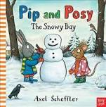  https://www.youtube.com/watch?v=ePMp8iHYV7k | What to do:  *Have a think of what Pip and Posy had to put on before they went out?  *What they both tried to catch on their tongue?  *What did Posy want to build, and what about Pip?  *What did Posy throw on Pip?  *What did Pip do after?  *How did both of them feel after?  *What did Posy do to Pip to cheer him up?  *Where did they go after?  Extension:  Can you try to draw yourself with your friend? | Ask an adult to upload the picture of your drawing/painting to show us your creation.  Let us know if you like the story about Pip and Posy.
Tuesday | Make a sensory zip up plastic bag.  You can find instructions here:  https://www.kiddicaru.com/blog/how-to-make-baby-sensory-bottles-bags/  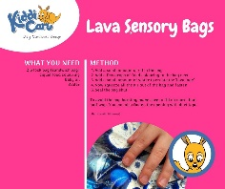  When page opens scroll down to find instructions for easy to make sensory bag. | What to do:  Look in the bag what can you see, is it sparkly, fluffy or colourful?  Does it have bubbles inside?  Extension:  Think about how it feels when you are playing with it.  Is it squashy, hard to squeeze or bumpy? | Upload a photo or video of you playing with your sensory bag  Let us know what you like about it or which bag is your favourite if you did more than one.
Wednesday | Baking shortbread  https://www.bbcgoodfood.com/recipes/shortbread-biscuits  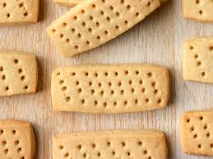 | What to do:  You will need an adult to help you bake some yummy shortbread biscuits!  Click on the link to find the simple recipe online. All you need is flour, butter and sugar.  Extension:  Can you cut the biscuits into shapes before baking them? | Get an adult to take a picture of you baking your yummy biscuits and share it on your Learning Journal.
Thursday | 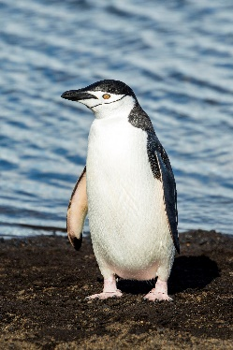  https://www.youtube.com/watch?v=He5Xu11HBkM | What to do:  Can you join in and copy the actions to this penguin song? Singing and dancing can make you feel good and makes us happy!  Extension:  Can you think of any other animals that live in the cold? Can you draw them?  Can you draw a picture of a penguin? | Get an adult to take a picture or a video to upload to your Learning Journal of you joining in with the dancing  Upload a picture of your penguin drawing to your Learning Journal.

