Inveralmond EYC and Ladywell NS Home Learning
Week Beginning 18th January, 2021
Planned weekly activities for home learning 2021
There is also a weekly sway you can access – a link to this will be issued separately
Hello everyone
We really hope you are having fun at home and had a lovely time over the holidays. Did you go out in the snow? We all did and managed not to fall over too many times! If you have any pictures of you out in the snow please post them onto your Learning Journal, we would love to see them.
This week we will read you stories and give you some ideas of things you can do with your family.
You can let us know whether you enjoyed the things we have shared by posting to your Learning Journal, we look forward to hearing from you.
Take care!
The Nursery Team
Day | Song /story (can be accessed on your child’s Learning Journal) | Experience / activity | Children’s feedback
Monday | 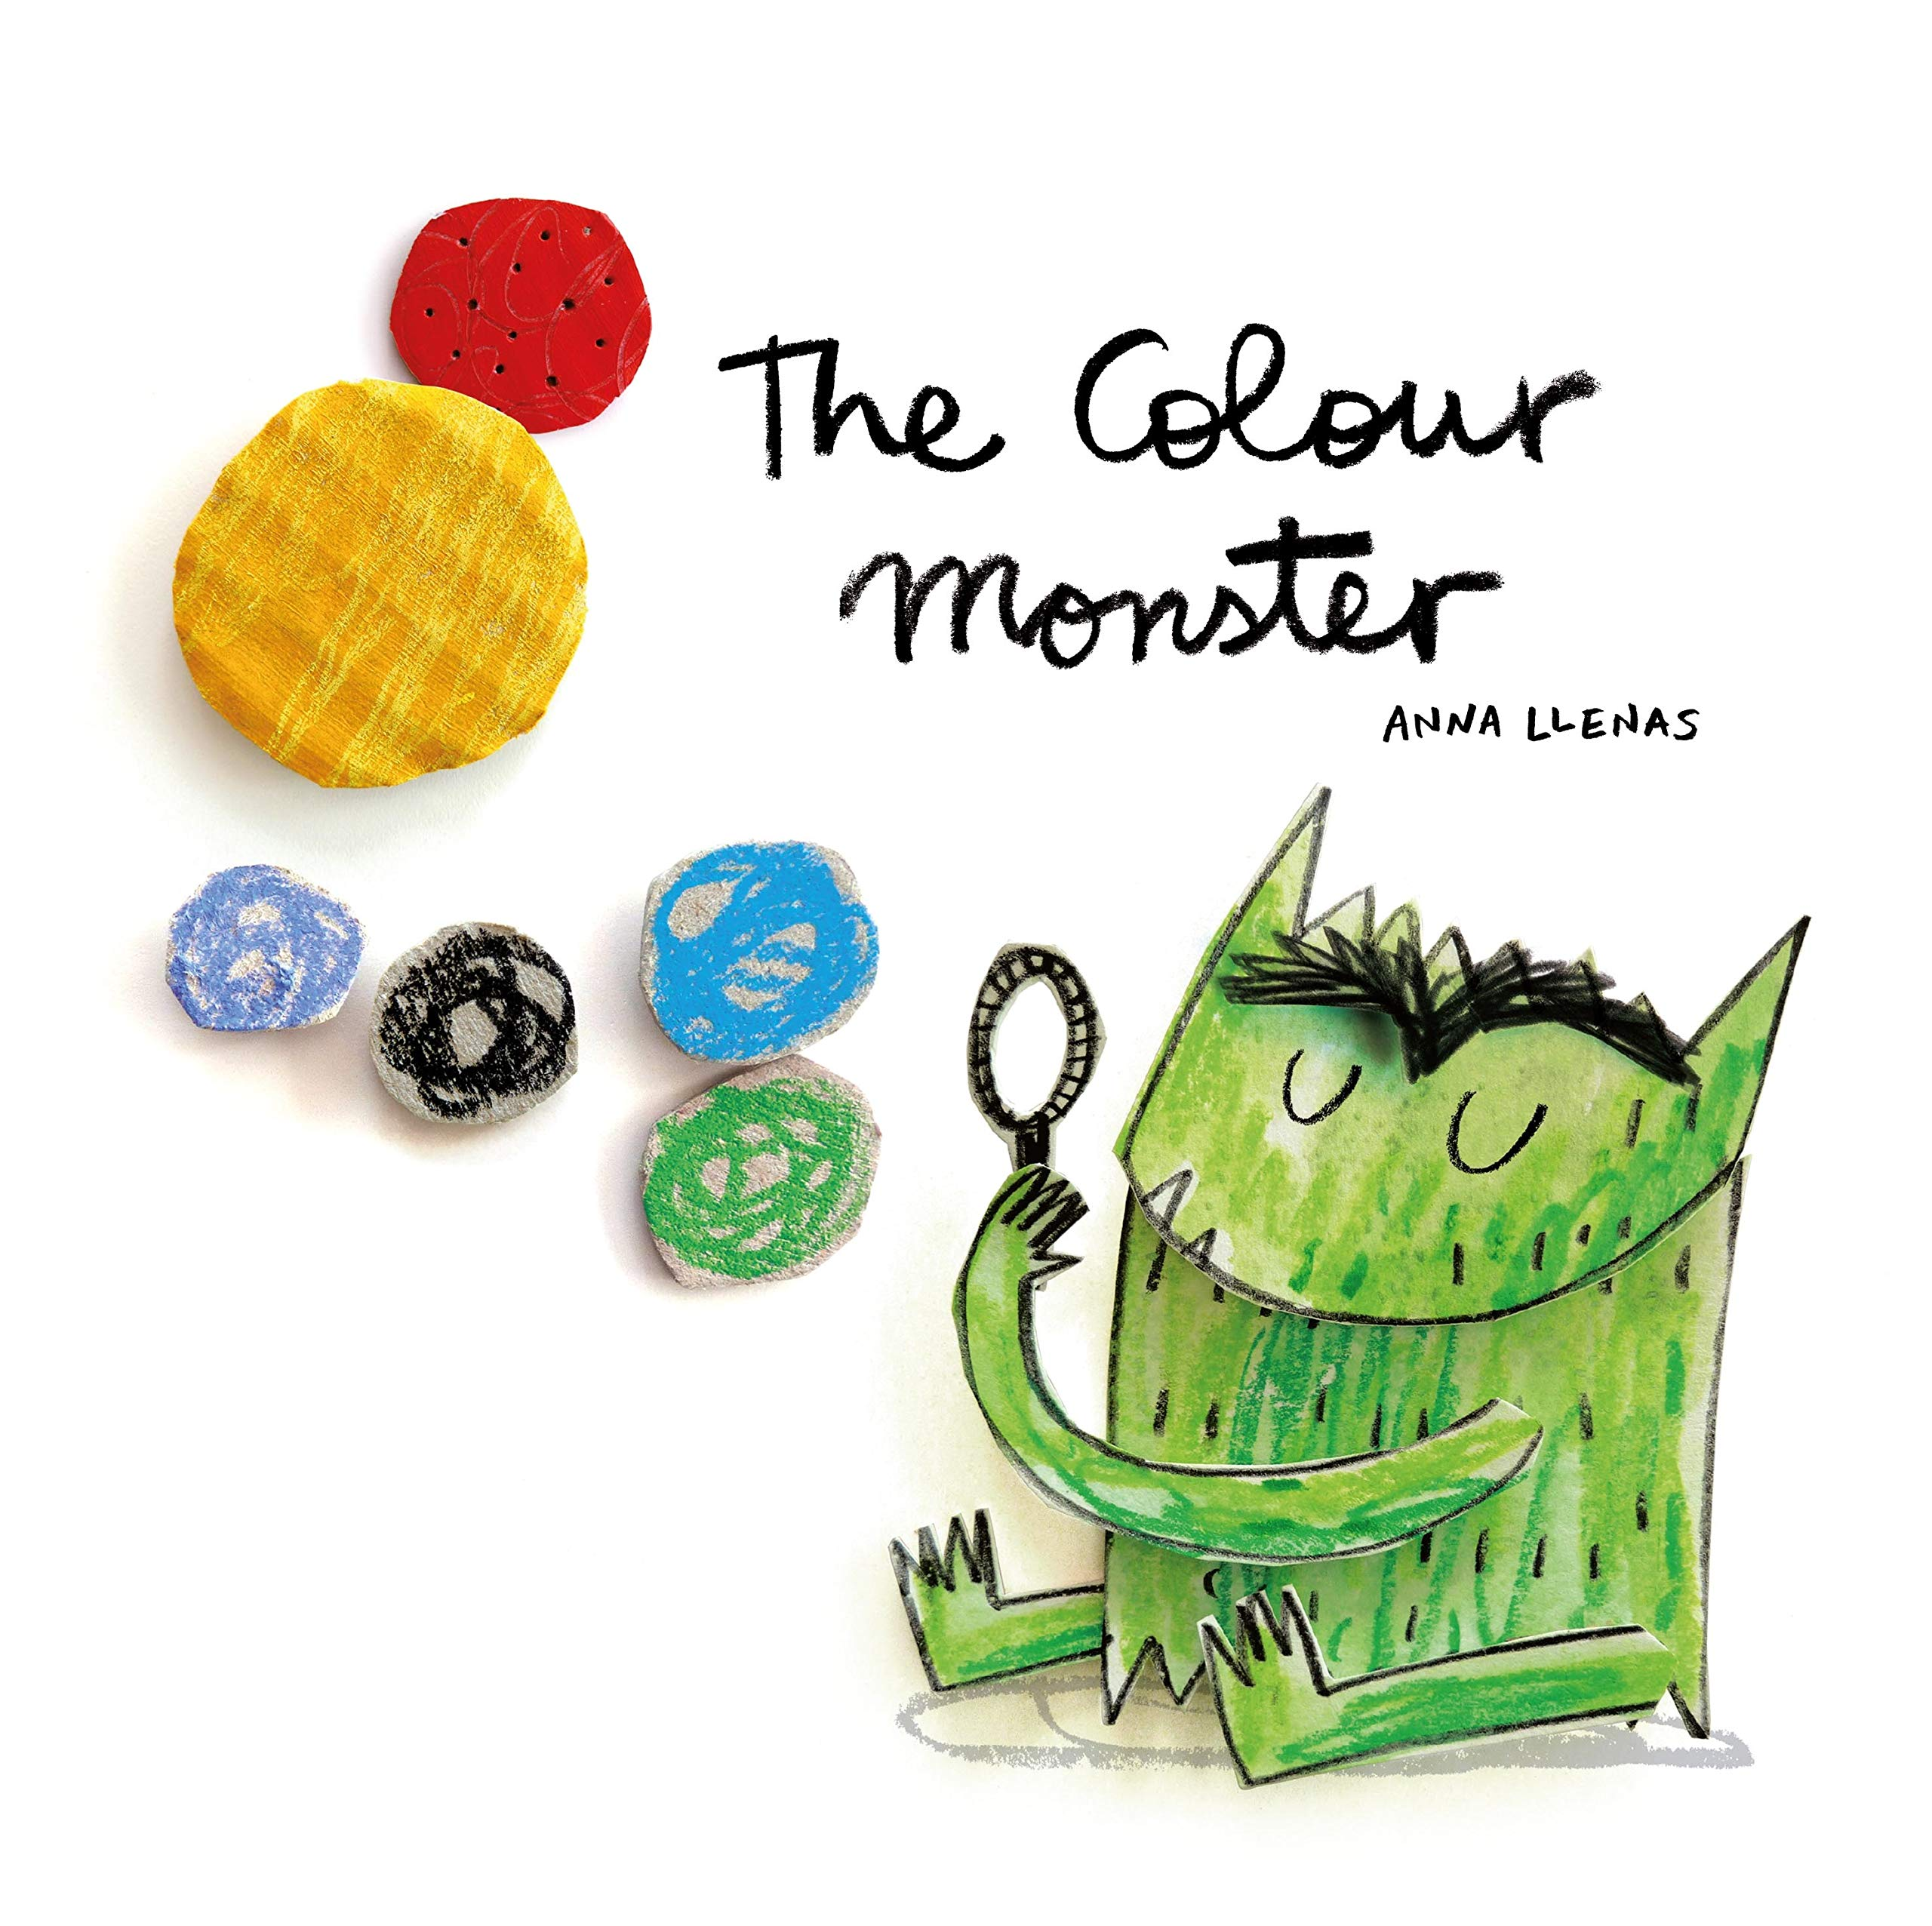  The Colour Monster  by Anna Lewis  Read by Sharon or Laura on Learning Journals | What to do:  Draw your own Colour Monster and tell us how you are feeling today and why.  Extension  Draw other colour monsters to show different feelings you may have.  Can you add your name to your picture?  Can you find things in your house that are the same colour as the different colour monsters in the story?  Can you sort different coloured items into groups? Sorting toys, clothes, pegs or packets in the food cupboard can be a good way to do this. | Tell us on your Learning Journal how you are feeling today and why.  Ask an adult to take a photograph of your colour monster and/or your sorting activity and upload it to your Learning Journal
Tuesday | https://www.youtube.com/watch?v=03zqJQJRLN0  Lyrics  We’re gonna shake, shake, shake our sillies out  Shake, shake, shake our sillies out  Shake, shake, shake our sillies out  And wiggle our waggles away | When you’re stuck inside for a lot of the day, it’s good to move around and burn off some energy!  Singing and dancing can be lots of fun and can cheer us up if we feel bored or sad.  What to do:  Join in with the actions to shake your sillies out and wiggle your waggles away!  What else cheers you up if you’re feeling sad or upset?  What did your body feel like when you were joining in the actions? Did you get hot? Did you start to breathe faster? Can you feel your heart beat if you hold your hand over it? What other things make you feel like this? | Tell us on your Learning Journal how you are feeling today and why.  Upload a photo or video of you joining in with the song.  Tell us what things make you feel happy.
Wednesday | Sesame Street: Name that emotion with Murray!  https://youtu.be/ZxfJicfyCdg | Watch the video clip with an adult.  See if you can guess how each animal is feeling before Elmo tells you the answer.  Can you pretend to feel that way too?  Look into a mirror and try making a happy face, a sad face or an angry face.  Play a game together. One person should act out a feeling and the other person has to guess what it is. | Tell us on your Learning Journal how you are feeling today and why.  Upload a photo of you making a happy, sad, surprised or angry face and see if your key worker can guess what the correct feeling is.  If you want to draw a picture about something that makes you feel happy or sad you can do that too. An adult can write on the picture what it’s about or tell us about this on your Learning Journal.
Thursday | 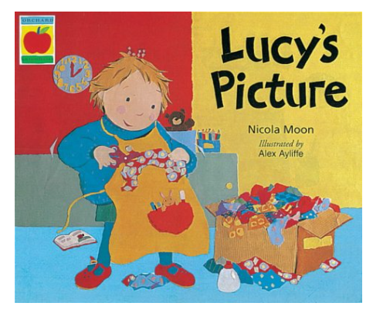  Lucy’s Picture  by Nicola Moon  Read by Zoe or June on Learning Journals | Lucy made a beautiful picture for her grandad that he could feel because he couldn’t see the picture. She enjoyed making it and I’m sure it made her grandad feel happy.  Acitvity  - Collect items such as leaves, fir cones, sticks and stones, while out walking or gather together different items you can find inside e.g. string, pegs, coins etc.  - You can google and look at some nature art by Andy Goldsworthy.  - Create a picture together by arranging the items. This can be inside or out – on the ground, paper or a table.  Extension  Create a gallery of different pictures – involve the whole household. | Tell us on your Learning Journal how you are feeling today and why.  We would love to see photos and videos of your pictures. Upload them to your Learning Journal.

