Looking at seeds
- Find a basket or a bag and go on a walk and collect conkers and acorns.
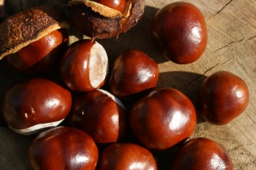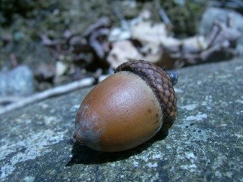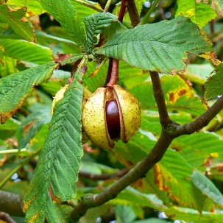
- Are there any signs that animals have been eating these seeds?
- Watch squirrels as they collect and then bury nuts and seeds for winter.
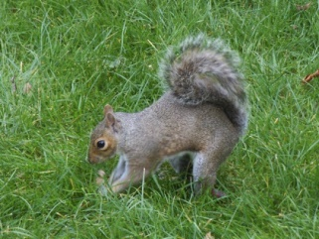
- Hunt for fir cones and find the seeds hidden inside them.
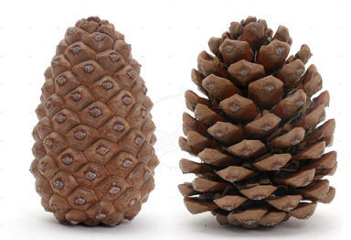
- Collect rosehip and pull them apart to look at the seeds inside.
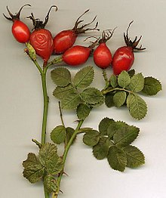
- Can you find any other seed pods outside? Can you open them to find the seeds inside?
- You may have to look really closely to see tiny seeds or use a magnifying glass.
- Make a picture with the seeds that you have found and the pods they have come out of

- Cut open an apple and look at the pips/seeds inside. You could plant them and grow a little apple tree!
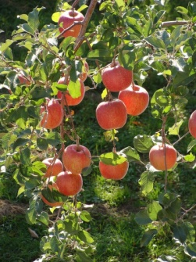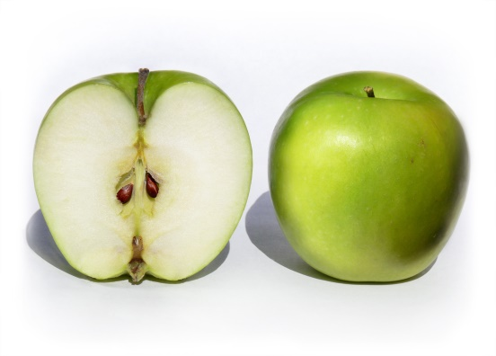
- Cut open a tomato and feel the wet seeds inside. Look inside a cucumber, a melon , a banana…can you find the seeds?
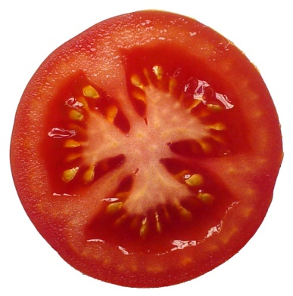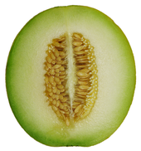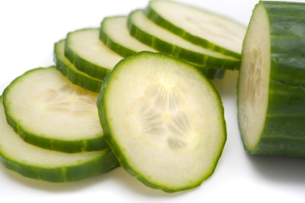
- Buy an avocado. It has an enormous seed. You can try and grow it by suspending it over a jar of water with cocktail sticks.
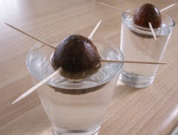
- Crack open a nut and discover the seed hiding inside
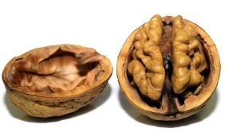
Don’t forget to wash your hands after touching any plants, berries, leaves or seeds.

