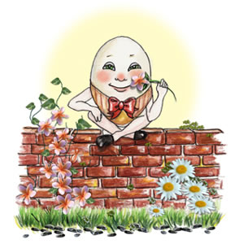

Humpty Dumpty sat on a wall,

Humpty Dumpty had a great fall,

All the King’s horses and

All the King’s men,

Couldn’t put Humpty together again.