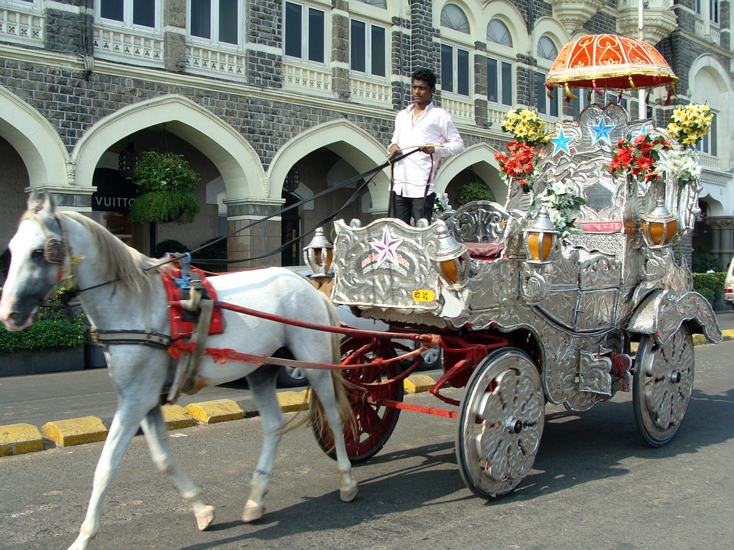

Horsey, horsey don’t you stop,

Just let your feet go clippety clop

Your tail goes swish ,

Your wheels go round.

Giddy up, giddy up,

We’re homeward bound