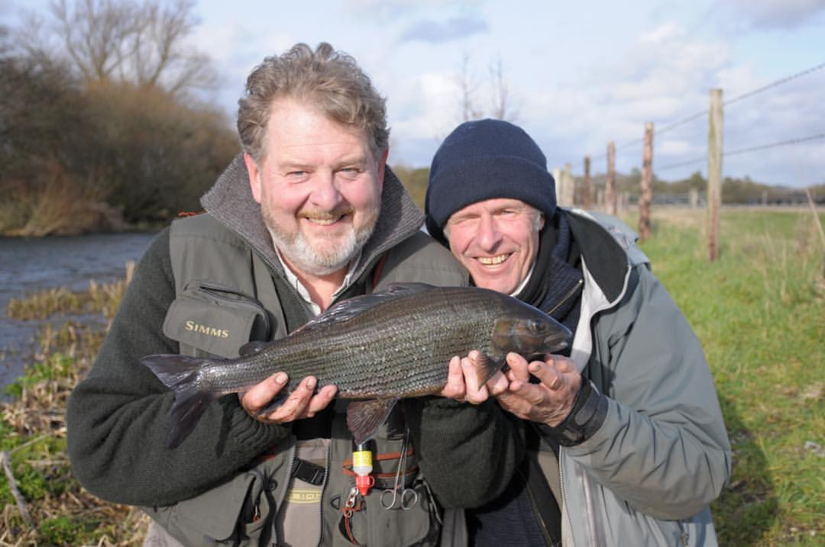

1,2,3,4,5.

1,2,3,4,5, once I caught a fish alive,

6,7,8,9,10,then I let it go again,

Why did you let it go?

Because it bit my finger so.

Which finger did it bite?

This little finger on my right.