Greenrigg Primary School

We love, we inspire, we grow
Together….we are Greenrigg

SCHOOL IMPROVEMENT PLAN
2019-2020

Safe Include Nurture Respect Team Courage

Factors Influencing the Improvement Plan

School Factors

Addressing Action Points identified in school’s Self Evaluation procedures – main focus is improving writing
Cluster Improvement Plan – development of writing
Consistency in learning and teaching, implementing recommendations of Improving Scottish Education
Flexible early learning and childcare implementation

Local Authority Factors

Moving Forward in Learning – Leadership for Improvement; Learning, Teaching and Assessment; Wellbeing and Inclusion; Early Years Framework
Raising attainment, including closing the gap (West Lothian Raising Attainment Strategy)
Transforming Your Council
Corporate Plan
Education Services Management Plan
West Lothian Parental Involvement and Engagement Framework
Increased entitlement to early years’ provision

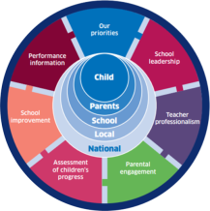
National Factors
Current Position

Next Steps

National Improvement Framework / Scottish Attainment Challenge / National Improvement Hub / Raising Attainment for All
Pupil Equity Funding
How Good is Our School? 4th Edition and How Good is Our Early Learning and Childcare
Getting it Right for Every child (GIRFEC)
Curriculum for Excellence
Developing Scotland’s Young Workforce
Building the Ambition
Child Protection Issues / Guidance
GTCS standards and professional update

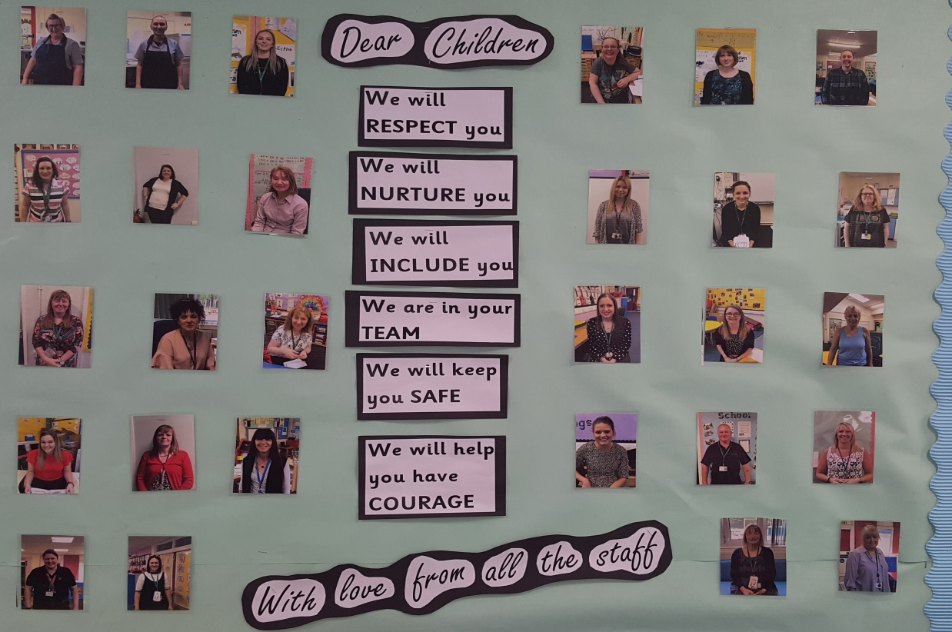

Additionality: Pupil Equity Funding Plan:
Closing the attainment gap between the most and least advantaged children

PART 1: Contextual Data Analysis & Rationale

Greenrigg Primary School is situated in the village of Greenrigg and is a non-denominational school catering for Nursery to P7. The village sits on the border with North Lanarkshire with a number of children coming to us from Harthill and Eastfield. We are also enrolling an increasing number of children from the Heartlands area. Greenrigg is in the Whitburn Cluster and feeds into Whitburn Academy. In addition, each year we have P7 children who move on to secondary schools in North Lanarkshire. The school is included in Decile Band 4.
This session we have 122 children in the school and 37 children in the nursery. Staffing consists of a shared Head Teacher, an Acting Consortium Depute Head Teacher from August – December, one Principal Teacher (who is also teaching nursery), 8 class teachers, a nurture teacher, a teacher covering RCCT in P1, P2 and P4/3, a part time additional support for learning teacher, a part time teacher leading numeracy, an early years officer, a part time nursery nurse, additional pupil support workers in the nursery, five pupil support workers, one instrumental instructor, two catering assistants, one administrative assistant, and one facilities management assistant. Children have had a drama specialist, a PE specialist and additional input in the upper school in music and French. There has been a need for everyone in the school community to be flexible in responding to changes which have included a number of staff absences this session (including the Head Teacher) and days lost through snow.
The quality of accommodation in the school is satisfactory. The outside of the building is in need of attention. The building has 6 classrooms, a good size nursery, four small office spaces, an assembly hall and small dining area. There is a small garden area within the school playgrounds and the nursery class has a small outdoor area. There is a Community Wing with two rooms and a lounge/sitting area. We use the sitting area for our Nurture Groups and the Wing is also used through Council Letting procedures by the Toddler Group, Community Council and Local Councillors. We are currently hosting a PPP group too. We have an active Parent Council and the children benefit from a range of additional resources and opportunities thanks to fundraising efforts led by the PTA.

- Background
From August 2018, the leadership of the school changed to the substantive Headteacher working Tuesday , Wednesday and Thursday of each week and the Principal Teacher as Acting Headteacher on a MOnday and Friday. At the present time (June 2019) there is an Acting Principal Teacher/Acting Headteacher in post, supporting the Headteacher in leading the school. For the past four years the development of numeracy has been a core festure of the school’s improvement work. The school has a positive valitdation of its work by West Lothian Council in September 2019. The VSE team found the following strengths in the school’s work; the leadership of change and the leadership at levels which permeates the school. As a result children, staff and stakeholders feel valued and respected. The quality of the learning experiences in the school, particularly in numeracy which are emsuring that children are making very good progress

- Data
Our data shows that overall, attainment in literacy and numeracy is good. By the end of P1, almost all children attain the appropriate CfE levels in listening, talking and reading. In writing most children achieve early level by the end of P1. By the end of P4 and P7 most children achieve the appropriate curriculum for excellence level in listening, talking, reading and writing. Our recent VSE team agreed with the school that there is particular scope to further improve the quality of children’s writing, and overall literacy attainment. Attainment in numeracy and mathematics is good. Attainment data shows that most children in P1, P4 and P7 are achieving in line with national expectations. With a consistent focus on numeracy through planned school improvement priorities children’s understanding of number and number processes will continue to be developed.

- What are our universal priorities and what is our ‘gap’? Who are our target groups and their barriers to learning?
A number of our identified children experience gaps due to ASD, early life experiences and ongoing family issues which have an impact on their aspirations for learning. Our target groups will be for identified children who experience barriers in literacy and numeracy, as well as a small number of identified children requiring support to maintain appropriate levels of attendance. Approximately 5% of pupils in school have a diagnosis of Autism Spectrum Disorder (ASD). Attainment for these pupils is significantly behind those of the rest of the school particarly in writing. There is scope for improving attainment by using more digital technologies to enable young people to demonstrate their learing

- Summary/overview of proposal & non-negotiable outcomes
We will continue to employ a highly effective Numeracy Development Teacher to lead all aspects of numeracy including targeted and universal assessments and interventions,. Pupil Support Workers (PSW) will be retained to provide focussed literacy and numeracy interventions for individuals and groups across the school where gaps have been identified.. The PT/Acting Head/Additional Support for Learning Teacher and PSWs will focus on small target groups of identified children who are in Quintile 1 or have ASD. These targeted interventions will be focussed on improving the attainment in literacy and/or numeracy with identified children. This will involve support for learning work, targeted supports in partnership with class teachers and also additional supports such as life skills and outdoor learning to help them to overcome barriers to learning and raise their aspirations for what they are able to achieve. We expect to see an increase in pupil attainment and decrease in off-task behaviours which disrupt learning. For ASD pupils we expect to see a calm, structured and predictable learning environment and a consistent approach to identifying, addressing and supporting their varied needs.

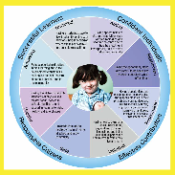
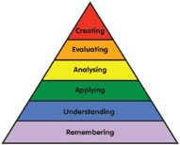
7 Principles
Challenge & Enjoyment, Breadth, Progression, Depth, Personalisation & Choice, Coherence, Relevance

Contexts for Learning

Ethos & Life of the school
French P1-P7 Signing across school
School vision, values and aims

Curricular Areas and Subjects
Core subjects: literacy & maths

Interdisciplinary Learning
Making connections across curriculum areas

Opportunities for Personal Achievement
1 + 2 Languages
Achievements in the classroom and beyond

Our School Values…
Safe Include Nurture Respect Team Courage

Curricular Areas

Skills for learning
Literacy & English
Mathematics & Numeracy
Health & Wellbeing Social Subjects Sciences Expressive Arts Technologies
Religious & Moral Education

Skills for work

Learning and Teaching

Interdisciplinary Learning
Skills
Achievements
Pupil Voice Groups

Skills for life
House Groups
Community Links

Active Learning
Collaborative Approaches Assessment is for Learning Outdoor Learning
Digital Literacy
Developing the Young Workforce
Challenge and Support
Floor Books
Eco Topics
Together Times
Literacy across all aspects of learning
Outdoor learning

Pupil Voice

Creativity

Pupil Leadership Team
School Sport Award
Extra-Curricular Clubs RAP Time
Assemblies / Shows /Nativity
Sports festivals
Choir
DYW – Pupils Leading
Parental Engagement

Successful Learners Confident Individual

Pupil Voice
Responsible Citizen Effective Contributors

Greenrigg School - School Improvement Planning for Ensuring Excellence and Equity
School priorities linked to NIF priorities  (observable, measurable outcomes which focus on learning, achievement and wellbeing) | NIF driver mapping  (check as appropriate) | Proposed Actions  (note any external supports e.g. Cluster, authority, RIC etc.) | By | Measures of Success  (include performance data, quality indicators and stakeholders’ views)
Raising attainment for all, particularly in literacy and numeracy:  All children receive regular, well-planned learning in Writing. Learning opportunities provide appropriate progression in Writing skills and high quality learning experiences.  All children experience opportunities to engage in reading for enjoyment every day, in different places, including listening to their teacher reading | ☐School Improvement  ☐School Leadership  ☐Teacher Professionalism  ☐Parental Engagement  ☐Assess. of Chdn’s Progress  ☐Performance Information | - Create driver diagrams focusing on development of writing and reading  - School will take part in Scottish Book Trust Reading accreditation programme  - Develop Writing CLPL based on staff needs  - Develop shared understanding of high quality learning, teaching and assessment experiences in Writing Implement and evaluate approaches. |  | Attainment in writing across the school – target 80%  85% of children reporting increased interest in reading for enjoyment
Closing the attainment gap between the most and least advantaged children:  Through targeted interventions 85% of our young people in Quintile 1 are achieving Second Level in Literacy and Numeracy by the end of P7  Increase in literacy attainment of young people with ASD particularly in writing | ☐School Improvement  ☐School Leadership  ☐Teacher Professionalism  ☐Parental Engagement  ☐Assess. of Chdn’s Progress  ☐Performance Information | - Implement PEF Numeracy Action Plan focussing on use of Maths Recovery approaches with identified groups  - Create driver diagram action plan focusing on use of digital literacies etc to enable young people with ASD to demonstrate their learning |  | Target achieved in CfE levels supported by ongoing tracking.
Improvement in all children and young people’s wellbeing:  Increase in pupils understanding of their own wellbeing, how to improve it and support in place for this  Children be able to talk about emotions | ☐School Improvement  ☐School Leadership  ☐Teacher Professionalism  ☐Parental Engagement  ☐Assess. of Chdn’s Progress  ☐Performance Information | Create driver diagram action plan  Develop use of ICE pack for tracking, teaching and learning wellbeing  Develop use of emotionworks for in class and in playground |  | Focus groups of young people evaluating PSE lessons on wellbeing leading to a 90% reported understanding of wellbeing indicators  Children able to identify next steps for themselves
Improvement in employability skills and sustained, positive school leaver destinations for all young people:  Young people in P5-P7 are taking an active leadership role in the school | ☐School Improvement  ☐School Leadership  ☐Teacher Professionalism  ☐Parental Engagement  ☐Assess. of Chdn’s Progress  ☐Performance Information | - Analysis undertaken with all stakeholders to identify required interventions / partnerships required |  | Children able to talk about their leadership roles and impact they have made  Children creating CVs in P5 – 7

