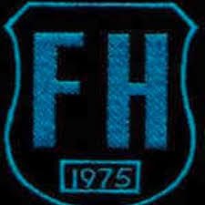
FALLA HILL VIRTUAL SPORTS DAY
Wednesday 10th June 2020

Welcome boys and girls to our Virtual Sports Day, we realise this is not our usual Sports Day event but hope that you enjoy taking part in the different activities and whilst we may be away from each other we are coming together as a School and House teams to see who will be our Sports Day Champions this year.

All the information for each activity is below along with your score sheet. Please make sure you are following the instructions for each activity that you choose to do and recording your score on your personal score sheet. There are 15 activities for you to choose from. The number of activities you compete in depends on your Stage Group, if you want to take part in more that is fine BUT please be aware we will only record your top scores to count towards House points.
So the number of activities you compete in are;
Stage Group | No. of Activities
P1 | 4
P2 | 6
P3 | 6
P4 | 8
P5 | 8
P6 | 10
P7 | 10

Our aim is to get everyone active on Wednesday 10th June and your teachers will be supporting this through Teams. However, we are aware that weather and time may play a factor in getting this completed so you will have until Wednesday 17th June to submit your scores on the Student Score sheet and email to the School office FAO: Mrs Doohan.
Please only submit the score sheet on your email and ensure it is completed with full details.
FOR YOUR SAFETY:
Please make sure that you are taking care performing any of the activities for Sports Day, wearing clothing that is suitable for PE Activities, your laces are tied and that you are being supervised appropriately.

We hope you have fun. We cannot wait to see all you get up to and good luck to everyone taking part!

The Falla Hill Staff

Falla Hill Primary School
Student Score Sheet
10th June 2020
Please make sure you complete the form below and return to Mrs Doohan via the school email FAO Mrs Doohan – Sports Day Results by 17th June, any results received after this time will NOT be counted.

Using the information in this document, that explains how to do each activity, complete the set number of activities for your stage group below. There are 15 activities to choose from so remember choose wisely. If you do more that’s ok but only your top scores will count.
Make sure you are recording your score correctly.
Stage Group | No. of Activities
P1 | 4
P2 | 6
P3 | 6
P4 | 8
P5 | 8
P6 | 10
P7 | 10

For your scores to count you must ensure ALL personal details are complete below;
Name |  | Class |  | House

Activity | Skipping (1 min) | Toe Touches  (30 sec) | Wall throw  (30 sec) | Speed Bounce  (20 sec) | Standing Long Jump | Target Throw  /10 | Jumping Jacks  (30 sec)
Your Score

Dribbling – Foot  (1 min) | Dribbling – hand  (1 min) | Throw & Catch  (1 min) | Racket hits  (30 sec) | Shooting  (1 min) | Shuttle Run  (5m x 20) | Chest push | Egg & Spoon  (5m x 5)

DEADLINE – 17 June to the school email address
wlfallahill-ps@westlothian.org.uk

ACTIVITY ONE:
SKIPPING
Equipment Needed:  Skipping rope  Timer/stopwatch | 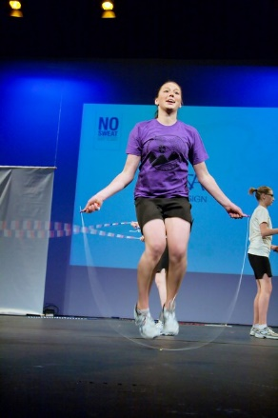
What you need to do;

You are going to skip non-stop for 1 minute counting how many skips you do.

Make sure you keep your hands wide either side of you like we have done in lessons
Give yourself plenty of space to skip
Keep going and don’t stop – Stamina and rhythm is key!

Maybe even play some music to keep you going!
Scoring sheet:

Write the number of skips you have achieved in the box labelled ‘Skipping’

ACTIVITY TWO:
TOE TOUCHES
Equipment Needed:  Timer/stopwatch | 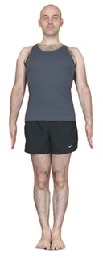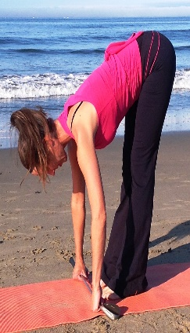  Stand Touch Toes Stand repeat
What you need to do;

You are going to see how many toe touches you can do in 30 seconds counting how many you do.

Starting in an upright position (Standing straight), bend down touch your toes and stand back up
That counts as 1 Toe Touch
Repeat as many times as you can in 30 seconds
Make sure you stand upright every time.

Scoring sheet:

Write the number of toe touches you have achieved in the box labelled ‘Toe Touches’
ACTIVITY THREE:
WALL THROW
Equipment Needed:  Ball that you can bounce against a wall  Clear wall and space  Timer/stopwatch | 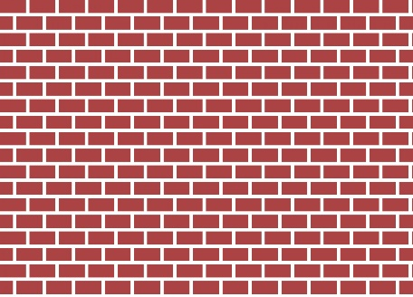  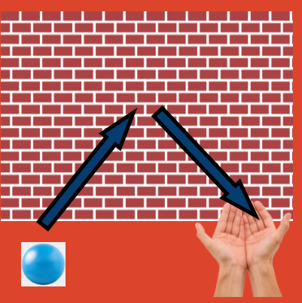
What you need to do;

You are going to see how many passes against the wall you can do in 1 minute

Stand facing the wall take 3 paces backwards away from the wall
When the timer starts throw and catch the ball against the wall as quickly as you can keeping a count for every successful catch against the wall

If you drop the ball that’s ok - keep going!
Scoring sheet:

Write the number of successful catches you have achieved in the box labelled ‘wall throw’

ACTIVITY FOUR:
SPEED BOUNCE
Equipment Needed:  Hurdle or towel or books  Timer/stopwatch | 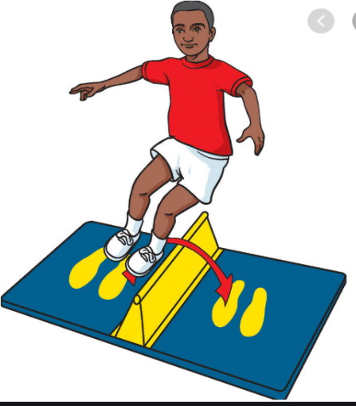
What you need to do;

How many times can you jump over the towel/books/hurdle in 20 secs. Use the video resource below to show you how to set this up correctly and safely,

Video Resource; https://youtu.be/jB1NWH0qpTA

Scoring sheet:

Write the number of jumps you have achieved in the box labelled ‘Speed Bounce’

ACTIVITY FIVE:
STANDING LONG JUMP
Equipment Needed:  Space  Marker to jump from  Clear landing spot  Measuring tape | 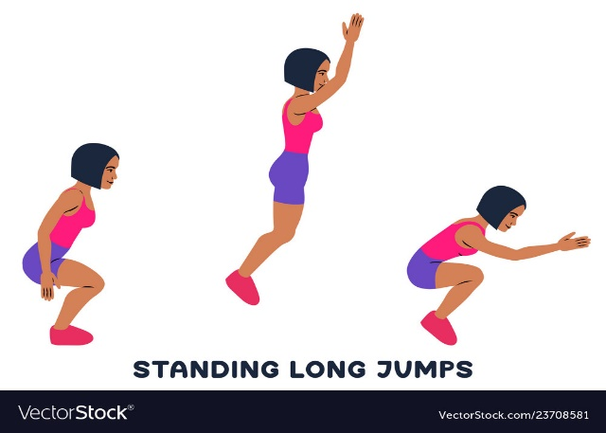
What you need to do;

How far can you jump? Using the link below to show you how to set this up. See how far you can jump from a standing position.

Remember to use your arms to help you jump and measure from the start point to the back of your heal where you first land.

Video resource: https://youtu.be/tf7YG9xwscA

Scoring sheet:

Write down how far you have jumped in metre/cm in the box labelled ‘Standing long jump’

ACTIVITY SIX:
TARGET THROW
Equipment Needed:  Space  Basket or object to throw into  10 balls, beanbags or rolled up socks | 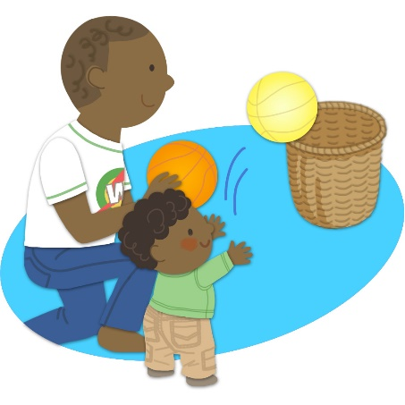
What you need to do;
You are going to see how many balls/socks you can get into the target.
Place your target/bin/washing basket 3 or 5 meters away from your start point

P1 – 3:
Start: 3m Basket

P4 – 7:
Start: 5m Basket

How many can you get in without missing?
Scoring sheet:

Write down how many you got out of 10 in the box labelled ‘Target throw’
ACTIVITY SEVEN:
JUMPING JACKS
Equipment Needed:  Space  Timer/stopwatch | 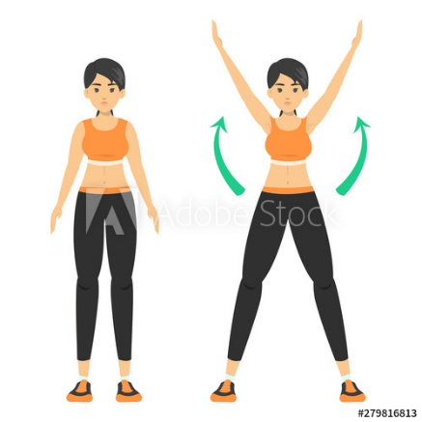
What you need to do;

You are going to complete a full jumping jack non-stop for 30 secs counting how many you do.

In a space starting with your feet together see how many jumping jacks you can do in 30 secs make sure you move your arms and legs out and back in to count as ONE

Scoring sheet:

Write the number of jumping jacks you have achieved in the box labelled ‘Jumping Jacks’

ACTIVITY EIGHT:
DRIBBLING - FOOT
Equipment Needed:  Football or general ball large enough to dribble with your foot  If you don’t have a ball you could use a rolled up pair of socks  2 markers  Timer/stopwatch | 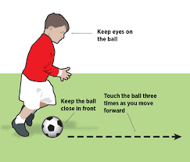  P1 – 3: 3m  P4 – 7: 5m
What you need to do;
You are going to dribbling the ball/socks with your feet from the start point, round a marker and back to the start to count as ONE

How many times can you do this in 1 minute?

P1 – 3:
Start: 3m Marker

P4 – 7:
Start: 5m Marker

Scoring sheet:

Write the number of full laps with the ball you complete in the box labelled ‘Dribble - foot’
ACTIVITY NINE:
DRIBBLING - HANDS
Equipment Needed:  Basketball or general ball large enough to dribble with your hand that bounces.  2 markers  Timer/stopwatch | 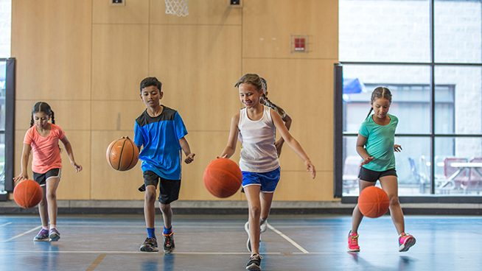  P1 – 3: 3m  P4 – 7: 5m
What you need to do;
You are going to dribbling the ball with your hand from the start point, round a marker and back to the start to count as ONE

How many times can you do this in 1 minute?

P1 – 3:
Start: 3m Marker

P4 – 7:
Start: 5m Marker

Scoring sheet:

Write the number of full laps with the ball you complete in the box labelled ‘Dribble - hand’

ACTIVITY TEN:
THROW AND CATCH
Equipment Needed:  Small ball or a pair of socks  Timer/stopwatch | 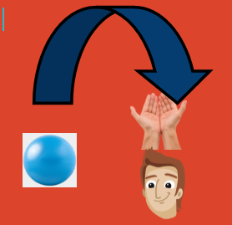
What you need to do;

You are going to throw and catch the ball/sock non-stop above your head for 1 minute counting how many you successfully catch. How many can you do?

Make sure you have plenty of space around you.
Throw the ball/sock up above your head (Not too high) and catch
A successful catch counts as one
If you drop it don’t worry just pick up and carry on
Scoring sheet:

Write the number of successful catches you have achieved in the box labelled ‘Throw & Catch’
ACTIVITY ELEVEN:
RACKET HIT
Equipment Needed:  Racket/bat  Ball  Or if you don’t have these you can use your hand with a balled up pair of socks or balloon  Timer/stopwatch | 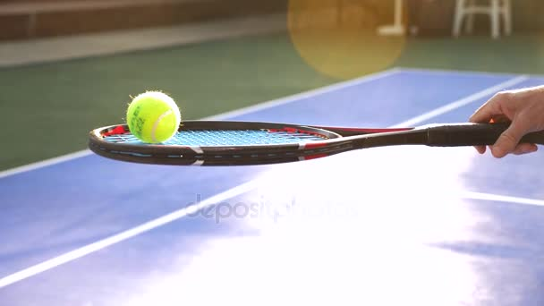
What you need to do;

You are going to see how many keepie ups you can do with the ball and racket non-stop for 30 sec counting how many you do.

Start with the ball on your racket/hand and every time you manage to keep the ball up in the air counts as one.

If you drop the ball don’t worry pick it up and keep going!

Scoring sheet:

Write the number of hits you have achieved in the box labelled ‘Racket hit’

ACTIVITY TWELVE:
SHOOTING
Equipment Needed:  Hoop or a bin/basket placed up high to act as a net  Ball or a pair of socks rolled up  Timer/stopwatch | 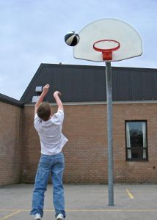
What you need to do;

How many shots can you get into the hoop in 1 minute?

P1 – 3: 3 strides from the hoop
P4 – 5: 4 strides from the hoop
P6 – 7: 5 strides from the hoop

Stand at your start point (See above for distance) after each shot make sure you go back to your start point to shoot. Every successful shot that goes in counts as one.

Scoring sheet:

Write the number of successful shots you have achieved in the box labelled ‘Shooting’
ACTIVITY THIRTEEN:
SHUTTLE RUN
Equipment Needed:  Markers  Measuring tape  Timer/stopwatch | 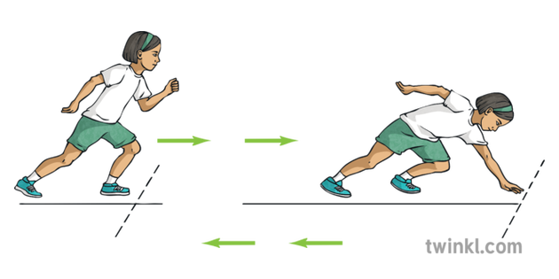
What you need to do;

How fast can you run a 5m distance 20 times? Use the link below to show you how to set this up.

You will need your Speed and agility when working on this task!

Video resource: https://youtu.be/_JlpNSOp8x8

Scoring sheet:

Write your time in minutes and seconds in the box labelled ‘Shuttle run’

ACTIVITY FOURTEEN:
CHEST PUSH
Equipment Needed:  Space – throwing area  Ball – football, basketball size preferably but any ball will do | 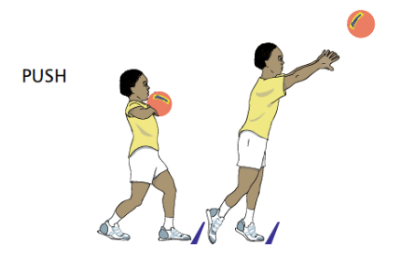
What you need to do;

In this throw you are going to push the ball with both hands from the chest into throwing area in front of you.

As in the diagram you use both hands to push the ball forward and measure from your start point to where the ball lands FIRST not where it ends up.

Throw 3 times and record your highest score.

Scoring sheet:

Measure your throw in meters and cm and write in the box labelled ‘Chest Push’
ACTIVITY FIFTEEN:
EGG & SPOON
Equipment Needed:  Markers  Spoon  Boiled egg or small ball or pair of rolled up socks  Timer/stopwatch | 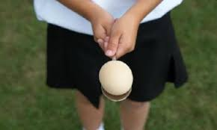
What you need to do;
You are going to balance the egg on the spoon from the start point, round a marker and back to the start to count as ONE

How many times can you do this in 1 minute without dropping the egg?

P1 – 3:
Start: 3m Marker

P4 – 7:
Start: 5m Marker

Scoring sheet:

Write the number of successful laps you have achieved in the box labelled ‘Egg & Spoon’

