Best Start Grant | School Age Payment
For Nurseries

Is your little one ready to leave us and take the next big step into P1?
If they were born 1 Mar 2015 - 29 Feb 2016 and you get certain benefits or tax credits, you could get £250 to help with the costs of starting school.
Find out more and apply at mygov.scot/beststart
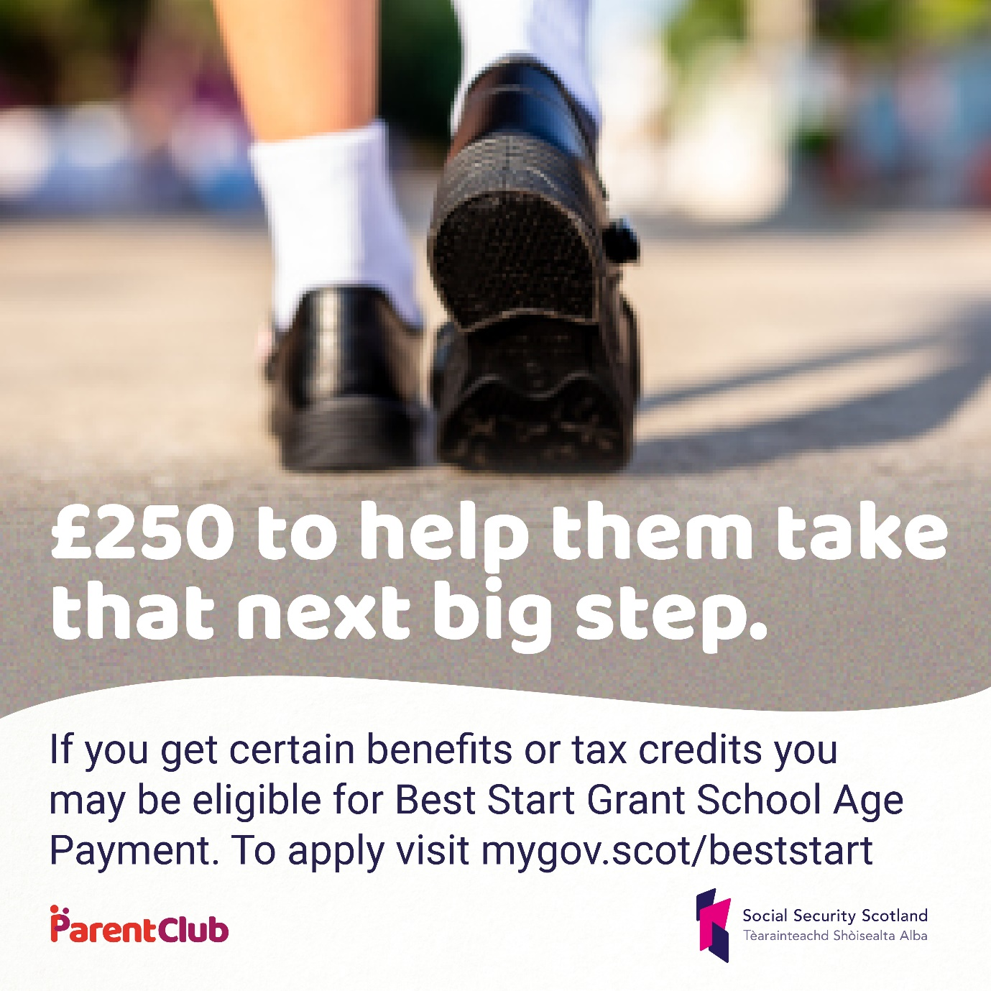

For Schools

The team at @HANDLE are looking forward to meeting all our new P1 pupils.
If your child was born between 1 March 2015 - 29 Feb 2016, and you get certain benefits or tax credits, you could get £250 to help with the costs of starting school Find out more and apply at mygov.scot/beststart

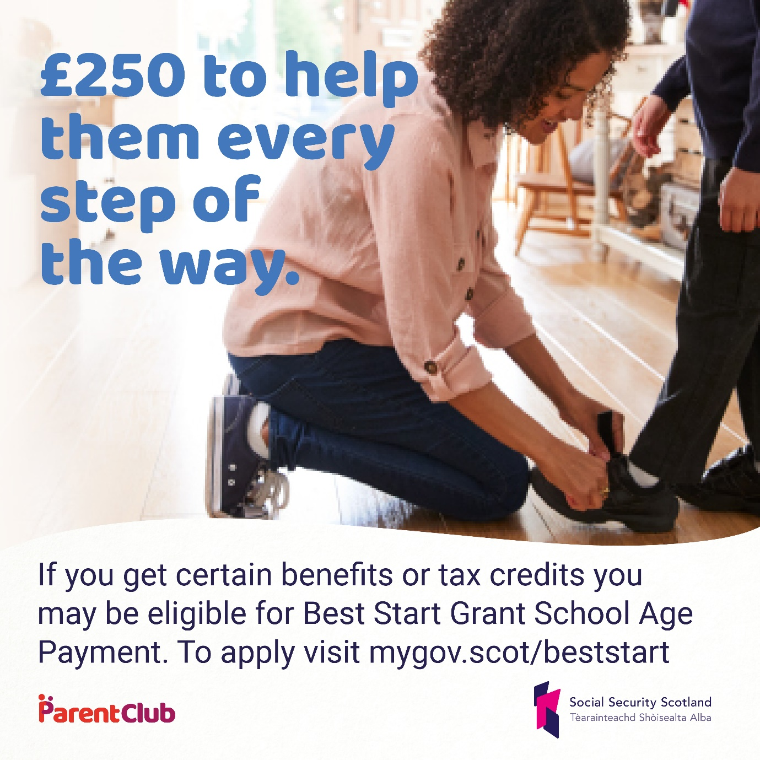

Families deferring

Are you deferring your child’s school place this year? Was your child born between 1 March 2015 - 29 Feb 2016?

You should still apply for School Age Payment from @SocSecScot between 1 June 2020 - 28 February 2021.

Apply now at mygov.scot/beststart

