P2 - Activities for Wks beg:

1st June and 8th June

|  |  |
| --- | --- |
| **Science – Minibeasts**  **Minibeasts**  Watch the power point about mini beasts. Make sure you watch on slideshow. Try to identify each creature. Now can you sort the minibeasts into two categories?  Adult: If you are unable to print the activities out then help your child to visually sort and record in their own way to group the minibeasts. | **Science – Minibeast**  Adult: re watch the power point with your child and discuss the various features of each minibeast. Now match the minibeast to the decription  Remember that you should keep looking for minibeasts when you go out walking.  You will find the minbeast description activity attached at the bottom |
| **French – your child should continue to practice the following:**  **Greetings with an adult or a sibling**.  Bonjour, Salut, S’il vous plait, Merci  **Ask the question and have your child respond to how they are feeling**  Comment ca va?  Ca va bien, Ca va tres bien, comme ci comme ca, ca ne vas pas  **Sing along to your favourite videos and play games**  <https://www.youtube.com/watch?v=lsc3qLMaCu8>  <https://www.youtube.com/watch?v=-4kNeFGBAcw>  <https://www.youtube.com/watch?v=Lpwf5N0rfVE>  New Work: Quel temps fait-il?  Adult: play the powerpoint on slide show and click on the centre for sound and pronunciation. Play the games as often as you like. Use the weather symbols or make your own and play    Now say 3 different weather statements to your child and have your child draw appropriate clothing or items for each one.  Il fait chaud  Il pleut  Il neige | Watch the powerpoint again.  Can you make your own weather forecast and present it to your family? Make some weather symbols. If you are able to print there is a map attached at the bottom. Or why don’t you design and make your own map. |
| **R.E.**  Adult: - Play the video of ‘The Lost Sheep’  <https://www.youtube.com/watch?v=rXAmdcAPpRs>  Talk about why the sheep was precious to the shepherd. Use ‘The Lost Sheep 1’ to draw about why the shepherd is watching over his sheep at night, | R.E.  Adult: - Re - play the video of ‘The Lost Sheep’  <https://www.youtube.com/watch?v=rXAmdcAPpRs>  Talk to your child about the deeper meaning of the story, the Christian belief that Jesus is the shepherd and he watches over us. Talk to your child about who in their family watches over them. Complete the worksheet, ‘The Lost Sheep 2’ |

Il fait gris



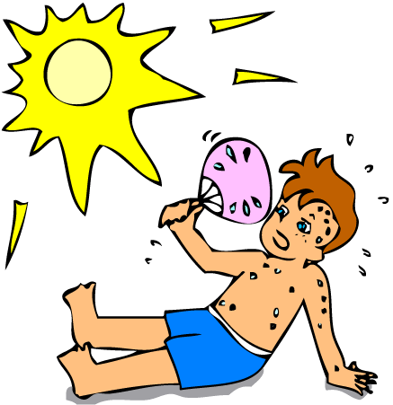













Il fait gris











