Phonics assessment – Name
Write 2 words with the sound and choose 1 to draw a picture of. The first one is done for you.
‘ss’ | ‘ch’ sound | ‘sh’ sound | ‘th’ sound
grass
pass
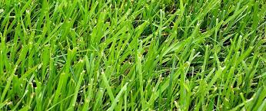

‘ee’ | ‘oo’ sound | ‘ing’ sound | ‘qu’ sound
‘ar’ | ‘wh’ sound | ‘ck’ sound | ‘ff’ sound

‘ai’ | ‘ay’ sound | ‘a-e’ sound

‘igh’ | ‘i-e’ sound | ‘ie’ sound

‘oa’ | ‘ow’ sound | ‘o-e’ sound

Read the words and draw a picture
sheep | king | read | brain
play | cake | knight | line

fries | goat | snow | bone

