P2 - Activities for Wks beg:

18th May and 25th May

|  |  |
| --- | --- |
| **Science – Minibeasts**  Watch the video to find out some facts about minibeasts before we start to have a closer look  <https://www.youtube.com/watch?v=LSp_meUwug4>  Adult: this is a chance to get your child to explore outside. Go for a walk and get your child to check for minibeasts. It would be good if your child could take some pictures of what they find, or draw some pictures to share. Your child should record what they find. | **Science – Minibeast**  Watch the power point and video about caterpillars, then complete the life cycle sheet. You could use junk materials/paper to make your own caterpillar, or you could design and colour using the caterpillar worksheet or draw and colour your own one. |
| **French – your child should continue to practice the following:**  **Greetings with an adult or a sibling**.  Bonjour, Salut, S’il vous plait, Merci  **Ask the question and have your child respond to how they are feeling**  Comment ca va?  Ca va bien, Ca va tres bien, comme ci comme ca, ca ne vas pas  **Sing along to your favourite videos and play games**  <https://www.youtube.com/watch?v=lsc3qLMaCu8>  <https://www.youtube.com/watch?v=-4kNeFGBAcw>  <https://www.youtube.com/watch?v=Lpwf5N0rfVE>  New Work: Quel temps fait-il?  Adult: play the powerpoint on slide show and click on the centre for sound and pronunciation. Play the games as often as you like. Use the weather symbols or make your own and play |  |
| **R.E.**  Adult: - Play the power point of ‘The Lost Son’ and discuss this with your child. Talk about the story. Children should write a sentence to match each picture part of the story. | R.E.  Adult: - Discuss with your child the fact that the younger son was given his money and came back to a great welcome after it was all spent, while the other son stayed at home. How would he have been feeling. What would his emotions be? (jealous, upset, angry, hurt feelings). Have your child write some sentences to describe, or scribe some sentences for your child. |

Il fait gris

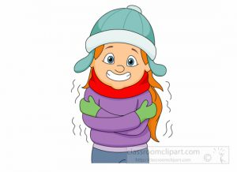

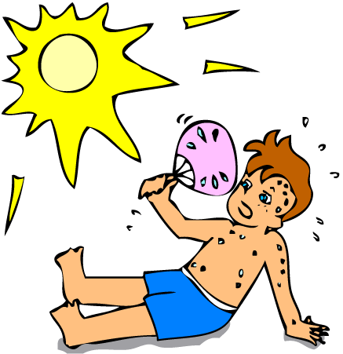





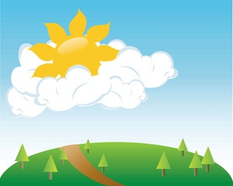

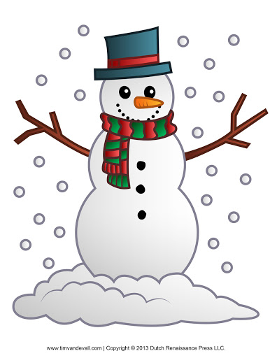





Il fait gris











