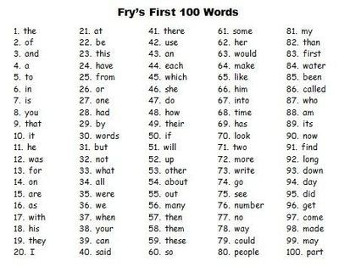
Practise 5 or 6 fry’s words a day. Practise reading them and spelling them properly.

