Nursery Newsletter
January - February 2015



Facebook
As many of you will already know, Eastertoun Primary and Nursery School has its very own Facebook page. This is a forum for information and positive discussions where you can find out what is going on as well as ask questions. The nursery will now be updating regularly using this forum so please follow the link below to see what we have and will be doing.
https://www.facebook.com/pages/Eastertoun-Primary-and-Nursery-School/515680291806459?rf=128007257249159


Glow
In the eventuality of the school being closed, the nursery staff will add some family activities you could be doing at home to our Glow Blog. These activities will be relevant to the interests of the children at the time and will derive from their current learning. Please follow the link below to view our page.
http://blogs.glowscotland.org.uk/wl/EastertounPrimaryLearningLog/

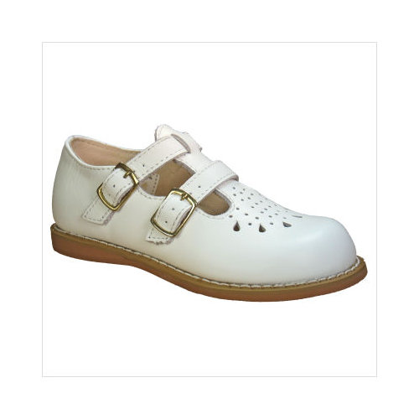
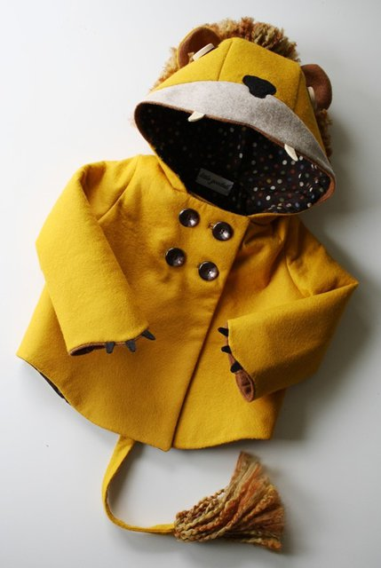

Shoes and Jackets
Your child’s time in the nursery, and the learning they do during this time, are of utmost importance to us as a nursery staff. Due to this we have decided to spend less time changing the shoes and jackets of the children. Although we feel this encourages independence within the children, it also takes up a lot of valuable learning and playing time. Therefore we have decided that we will only change the shoes of the children, not dress them for leaving the nursery. As before, it will help immensely if you could encourage your child to be changing their own shoes at home and send them to nursery wearing shoes you know they can put on independently.
At the end of a session, as you collect your child, you will then be asked to dress them for leaving the building.
At this time it would be appreciated if you could leave buggies at the bottom of the ramp. This will ensure the space within the nursery is available for parents and carers to change children. We understand that many would not want to leave children outside so please bring them into the building where nursery staff will be happy to help you.
We hope you understand our reason for making this change; please know the education of the children is at the heart of this decision.


Snack Prices and Payment
AM Price - £1.10 a week or £12.10 for the term.
PM Price - £1.00 a week of £11 for the term.
Please give all money to the person taking the register in the morning. No money will be taken at other times to ensure all payments are recorded.

Bump Stickers

As an additional safety measure we have decided to put a sticker on every child who has bumped their head. This will ensure that parents, carer and all nursery staff are extra vigilant around a child who has received a head knock. This will always be accompanied by our current letter which parents and carers are asked to sign on collection of their child.

Spare Clothes
We are currently running extremely low on clothing for children. If you have any of the nursery clothes at home we would appreciate if you could return them to nursery. Also, if you have any old clothes you are able to donate we would very much appreciate it. We are particularly low on socks and boys trousers.


Address and Telephone number
After a visit from our community Police Officer, PC Woolin, and as part of our coming projects we would like to ensure all children know their address and a contact phone number if possible. It would be fantastic if you could talk about this at home and what your child should do if they ever get lost. We will be beginning to support this learning in the nursery as we cover building, safety and Scottish topics.

Over the coming week we would appreciate if children could bring a photo of the type of house/flat they live in. If you do choose to send in a photo, please write your child’s name on the back of it.

Mrs Patience is having a Baby!
We are sure most of you have already noticed that Mrs Patience is expecting her second child, the children certainly have! She plans to finish working in the nursery on Friday 20 February, all things being well. At that time Miss Mulvaney, already a familiar face around the nursery, will be taking over her role as Nursery Teacher. She is excited to be in the nursery full time and looks forward to working with you all. Mrs Patience has promised to bring the baby in to meet the children once it has arrived safely. Addition


Stay and Play
Following the success of our last, ‘Stay and Play’ we would like to invite you back again to play with your child and view their Learners’ Journey. The children really enjoyed your visit last term and look forward to seeing you all again. The next ‘Stay and Play’ will be on week beginning Monday 2 March 2015. Again we will split the sessions into different groups on different days:
Monday – Red Group – Mrs Patience
Tuesday – Blue Group – Mrs Lynch/Mrs Craig
Wednesday – Green Group – Mrs Gardner
Thursday – Yellow Group – Mrs Patterson


Dates for your Diary
Monday 26 January – Scottish week begins

Wednesday 28 January – Nursery Burns Supper

Friday 13 February and Monday 16 February –
The Nursery will be closed for the February holiday

Thursday 19 February – Chinese New Year will be celebrated in nursery

Monday 2 March – Stay and Play week begins

