Make a paper mache dino egg!

<https://www.youtube.com/watch?v=ts4g-OFfiaU>

Imagine you are an archaeologist and you have discovered the bones of a never seen before dinosaur! Can you draw what the dinosaur would have looked like? Give it a Dinosaur sounding name! What did it like to eat?

**Date issued: 15.6.20/16.6.20**

Research at least 3 different dinosaurs and make a non-fiction dinosaur fact book!

Find out where dinosaurs remains were found. Can you find these on a map? Were any found in Scotland?

<https://www.bbc.co.uk/newsround/43627012>

Can you name some Dinosaur Movies? If possible watch some! They are very informative, and fun!

Find out what happened to the dinosaurs. Draw a picture to illustrate your findings.

Make a Playdough and Pasta dinosaur! 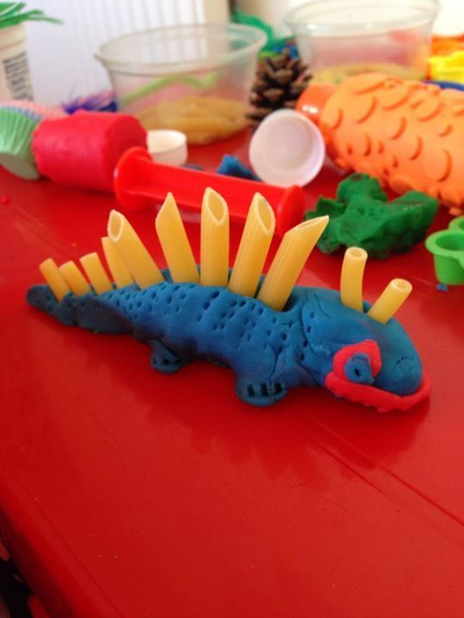

Easy Play dough recipe

<https://www.youtube.com/watch?v=oAIAm6BF0fs>

**Mini Topic-Dinosaurs!**

**Mrs Stenhouse was watching Jurassic Park on TV and was inspired to create a Dinosaur Topic for this week! As always you DO NOT have to do everything!**

**Mrs Stenhouse x**