Jeffers Reading: Thursday 11th June – Wednesday 17th June
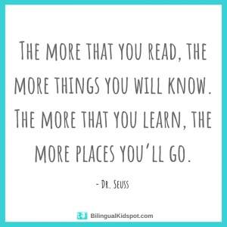
All these books are on active learn. Login to access your area.
https://www.activelearnprimary.co.uk/login?c=0
You will need – username, password and school code.

TYPE OF BOOK | TITLE | ACTIVITIES
Phonics | On the farm | - Read through front page.  - Read the book  - Back of book activities  - Bug Time!
Guided | This is my pet | - Read through front page.  - Read the book – using the Guided Reading sheet: session 1  - Back of book activities  - Fact file  - Make it!  - Bug Time! – look out for the bug face.  Follow up worksheet – complete in jotter.
Independent | At the dentist | - Read through front page.  - Read the book  - Back of book activities  - Bug Time! – look out for the bug face.

