Carle Reading: Thursday 11th June – Wednesday 17th June
All these books are on active learn. Login to access your area.
https://www.activelearnprimary.co.uk/login?c=0
You will need – username, password and school code.
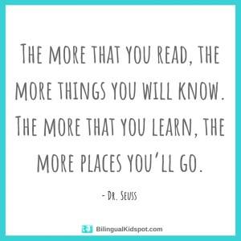

TYPE OF BOOK | TITLE | ACTIVITIES
Phonics | No Lunch! | - Read through front page.  - Read the book  - Back of book activities
Guided | We can do it! | - Read through front page.  - Read the book – using the Guided Reading sheet: session 1  - Back of book activities  - Can you spot?  - Try it!  - Bug Time! – look out for the bug face.  Follow up worksheet – complete in jotter.
Independent | A Picnic | - Read through front page.  - Read the book  - Back of book activities  - Bug Time! – look out for the bug face.

