Limes writing plan – Friday 5th June 2020 complete in your literacy jotter.
LI – I am learning how to write instructions.  SC – I can write four numbered instructions explaining how to brush my teeth. | Have you brushed your teeth yet? If not go and do it now but if you have a talk about it. Talk to your grown up about what you do starting each sentence with a bossy verb. You can use the ones in the wordbank. |  | Step 1: Date and title  Write the long date on the top line and title on the second line and underline.  Friday 5th June  How to brush your teeth |  |  |  | Step 2: Add a goal  Today we are going to add a goal.  This tells people what they will be able to do after reading the instructions. Write this on the first line under the drawing area in your jotter.  Goal  To tell people how to brush their teeth.
WORDBANK – bossy verbs
Wet Brush
Put Spit
Step 3: Draw a picture plan in your jotter.  (split the picture area into four)  Draw four pictures to show the process of making some toast. For example  - Wet your toothbrush.  - Put on some toothpaste.  - Brush your teeth.  - Spit out the toothpaste. | Step 4: Talk through the steps.  It’s ok if you want to add more detail.  Use the wordbank words as sentence starters. | Step 5: Write what you need  What do you need in each picture? Now add a label.  Toothpaste  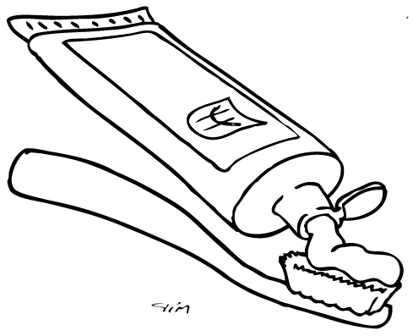Toothbrush |  |  | Step 6: Materials list  Add a materials list to your instructions  Write Materials as a heading and list all the things you need with a bullet point in the order you will need them.  Materials | Step 5: Write your instructions  Write Steps as a heading  Start each instruction with a number.  Use the wordbank words as sentence starters. Write them on a piece of paper to copy. They should sound out the other words themselves or use their sight word tins.  REMEMBER  - CAPITAL at the start of each sentence  - FULLSTOP at the end of each sentence  - FINGER SPACES between each word
FOR PARENTS  We do emergent writing. Your child will not be able to spell everything correctly and that is ok.  Just encourage them to sound out the words they want to write or use the wordbank. | Focus them on using CAPITAL at the start of each sentence, FULLSTOP at the end of each sentence and FINGER SPACES between words. |  |  | Writing Example (for structure only)  See below |  |  |  | Writing structure  - Title  - Materials  - Steps

How to brush your teeth.
Goal
To tell people how to brush their teeth.
Materials (put them in the order they will use them)
- Toothbrush
- Toothpaste
- Water
- Towel
Steps
- Wet your toothbrush.
- Put on some toothpaste.
- Brush your teeth.
- Spit out the toothpaste.

