Bananas writing plan – Friday 5th June 2020 complete in your literacy jotter.
LI – I am learning how to write instructions  SC – I can write numbered instructions explaining how to brush my teeth using time connectives to start each sentence |  |  | Have you brushed your teeth yet? If not go and do it now but if you have a talk about it. Talk to your grown up about what you do starting each sentence with a bossy verb. You can use the ones in the wordbank.  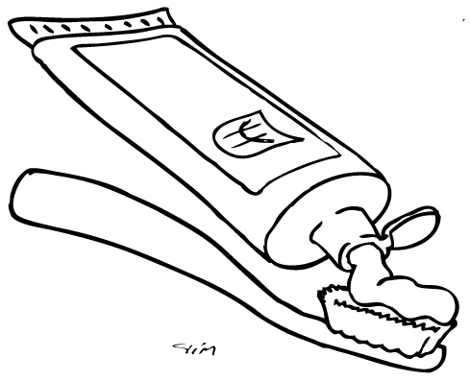 |  |  |  | Step 1: Date and title  Write the long date on the top line and title on the second line and underline. LI goes on the third line but do not underline.  Friday 15th May  How to brush your teeth.  LI: I am learning how to write instructions for brushing my teeth.
WORDBANK – imperative verbs
They should be able to work these out themselves but if they are struggling.
Wet Brush
Put Spit
wipe
Step 2: Goal  Write the goal | Step 3: Talk through the steps.  Use imperative verbs to start each instruction. | Step 4: Write what you need  Write what materials you will need  Materials |  | Repeat step 3 |  | Step 5: Write your instructions  Write Steps and then your instructions underneath.  REMEMBER  - CAPITAL at the start of each sentence  - FULLSTOP at the end of each sentence  FINGER SPACES between each word  Now add a picture underneath.
FOR PARENTS  Your child will not be able to spell everything correctly first time and that is ok. At the end choose three misspelled words for them to check online or in a dictionary –SPELLING CHALLENGE.  Just encourage them to sound out the words they want to write or use the wordbank. |  |  | At the end check for  CAPITAL at the start of each sentence, FULLSTOP at the end of each sentence and FINGER SPACES between words. . |  | Writing Example (see below)  Colours only to show structure. Do not copy in writing. Prompt questions are to encourage adding in more detail. (In brackets)  Writing structure  - Title  - Goal  - Materials  - Steps

How to brush your teeth.
Goal
To tell people how to brush their teeth.
Materials (put them in the order they will use them)
- Toothbrush (tell me more about the toothbrush. What colour is it? Is it a special themed one?)
- Toothpaste (tell me more about the toothpaste. What flavour is it? What kind is it?)
- Water
- Towel (tell me more about the towel?)
Steps
These are basic instructions encourage them to extend their sentences by using a word chosen from the list below.
Remember to Don’t forget to
Make sure until
and with the
so you Be careful not to
- First get your toothbrush and toothpaste out of the cupboard.
- Second put some toothpaste on your toothbrush.
- Next wet it under the tap.
- Now brush your teeth.
- Then spit out the toothpaste.
- Now wipe your face.
- Finally put your toothbrush and toothpaste away.

