Apples writing plan – Friday 5th June 2020 complete in your literacy jotter.
LI – I am learning how to write instructions.  SC – I can write five numbered instructions explaining how to brush my teeth. |  | Have you brushed your teeth yet? If not go and do it now but if you have a talk about it. Talk to your grown up about what you do starting each sentence with a bossy verb. You can use the ones in the wordbank.  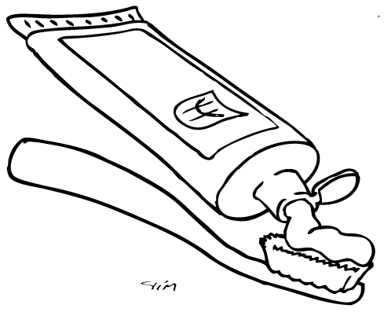 |  |  |  |  | Step 1: Date and title  Write the long date on the top line and title on the second line and underline.  Friday 5th June  How to brush your teeth
WORDBANK – bossy verbs
Wet Brush
Put Spit
wipe
Step 2: Goal  Write the word Goal on the next line then underneath. Try to write your own goal today.  Goal  To tell | Step 3: Talk through the steps.  Use the wordbank words as sentence starters. |  | Step 4: Write what you need  Write Materials on the next line and write a list of what you need with a bulletpoint at the start of each item. Write them one underneath the other.  Materials |  | Repeat step 3 | Step 5: Write your instructions  Write Steps then your numbered instructions underneath.  Start each instruction with a number and use the wordbank words as sentence starters.  REMEMBER  - CAPITAL at the start of each sentence  - FULLSTOP at the end of each sentence  - FINGER SPACES between each word  Now add a picture underneath.
FOR PARENTS  Your child will not be able to spell everything correctly and that is ok.  Just encourage them to sound out the words they want to write or use the wordbank. Afterwards choose two words to check the spelling of in a dictionary or online– SPELLING CHALLENGE.  Focus them on using CAPITAL at the start of each sentence, FULLSTOP at the end of each sentence and FINGER SPACES between words. |  |  |  | Writing Example (for structure only)  See below for reference only. Please encourage them to write their own instructions.  Colours only to show structure. Do not copy in writing. |  |  |  | Writing structure  - Title  - Goal  - Materials  - Steps

How to brush your teeth.
Goal
To tell people how to brush their teeth.
Materials (put them in the order they will use them)
- Toothbrush
Sentence Challenge
Today’s challenge is to try and make your sentences longer.
Maybe you could use the connectives with to tell me more.
Maybe you could tell me how you are doing something.
You could use
carefully

- Toothpaste
- Water
- Towel
Steps
- Wet your toothbrush.
- Put on some toothpaste.
- Brush your teeth.
- Spit out the toothpaste.
- Wipe your face.

