Do we are going to design out own birds. You can draw it, paint it, build it, make it.  Use any materials you have at home or can collect.  RESEARCH – look up pictures of different birds online to get some ideas. |  |  | Join in with Joe Wicks Daily workout  Live at 9am or see it on youtube later.  https://www.youtube.com/channel/UCAxW1XT0iEJo0TYlRfn6rYQ  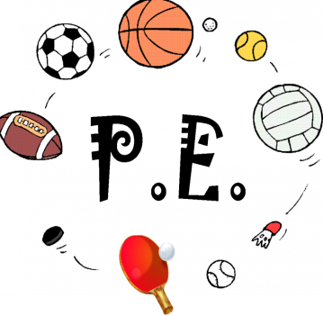
Friday Joke  Post your answers in the comments on the riddles tweet.  Joke – What do you call a dentist who doesn’t like tea?  Answer – Denis! | Friday 5th June  05.06.20  Daily Overview  Your activities for today.  Have fun! |  |  | Literacy – procedure writing  See writing plan.
 | Finish off Friday
Have a great weekend!! |  | Random Acts of Wildness  Check out twitter for your individual and family Random Acts of Wildness. |  |  | Help out at home  Sort the washing!  Help your grown up sort the washing either to put in the wash or to put away.

