Seuss Reading: Thursday 4th June – Wednesday 10th June
All these books are on active learn. Login to access your area.
https://www.activelearnprimary.co.uk/login?c=0
You will need – username, password and school code.
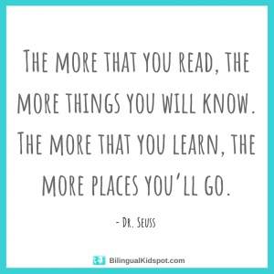

TYPE OF BOOK | TITLE | ACTIVITIES
Guided | Yun and the Ice Spirit | - Read through front page.  - Read the book – using the Guided Reading sheet: session1.  - Back of book activities  - Can you see?  - Do it!  - Bug Time! – look out for the bug face.  Follow up worksheet – complete in jotter.
Independent | Can you do this? | - Read through front page.  - Read the book  - Back of book activities  - Fact file  - Do it!  - Bug Time! – look out for the bug face.
Comprehension | A postcard from Mo Farah. | - Read text  - Answer questions in your jotter. Remember to answer in full sentences.

