Kerr Reading: Thursday 4th June – Wednesday 10th June
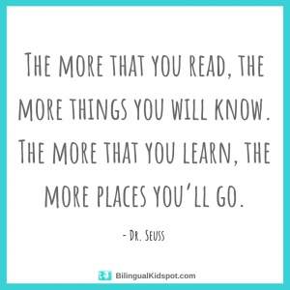
All these books are on active learn. Login to access your area.
https://www.activelearnprimary.co.uk/login?c=0
You will need – username, password and school code.

TYPE OF BOOK | TITLE | ACTIVITIES
Phonics | Munching Lunch | - Read through front page.  - Read the book  - Back of book activities  - Bug Time! – look out for the bug face.
Guided | Rat and Cat in Let’s Jump! | - Read the front page  - Read the book  - Back of book activities  - How many?  - Draw it!  - Bug Time! – look out for the bug face.

