Science – My Body  Over the next few weeks we will be looking at our bodies.  P1’s will be learning about My Senses  P2/3 will be extending their learning on senses and learning about organs in the body.  See group planning sheets. |  | Join in with Joe Wicks Daily workout  Live at 9am or see it on youtube later.  https://www.youtube.com/channel/UCAxW1XT0iEJo0TYlRfn6rYQ  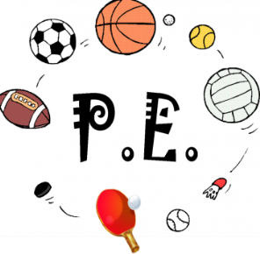
Numeracy  See group planning sheets  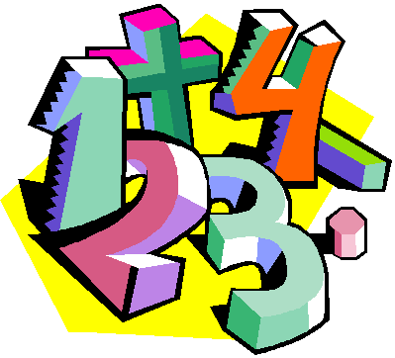 | Thursday 4th June  04.06.20  Daily overview  Have fun! |  | Literacy – sight words (P1), reading (all)  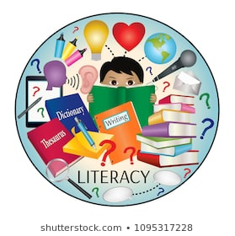  Reading  Each week we will allocate a number of books to do throughout the week.  Please just do them as and when you can. There is no expectation to do them all on a Thursday when they are set.  There looks like a lot on the sheet but most of the tasks are quick and talking based.  USE YOUR ACTIVE LEARN LOGIN  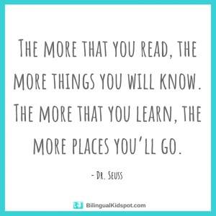
Random Acts of Wildness  Check out twitter for your individual and family Random Acts of Wildness. | Please post two things every day on twitter so we know how you are getting on.

