Seuss Reading: Thursday 28th May – Wednesday 3rd June
All these books are on active learn. Login to access your area.
https://www.activelearnprimary.co.uk/login?c=0
You will need – username, password and school code.
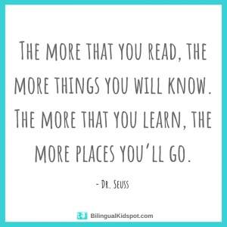

TYPE OF BOOK | TITLE | ACTIVITIES
Guided | Pete’s Peculiar Pet Shop: Just the Job | - Read through front page.  - Read the book – using the Guided Reading sheet: session1.  - Back of book activities  - Memory Mangle!  - Draw it!  - Bug Time! – look out for the bug face.  Follow up worksheet – complete in jotter.
Independent | Origami | - Read through front page.  - Read the book  - Back of book activities  - Fact file  - Make it!  - Bug Time! – look out for the bug face.
Comprehension | Paul the Lucky Octopus | - Read text  - Answer questions in your jotter. Remember to answer in full sentences.

