Science – My Body  Over the next few weeks we will be looking at our bodies.  P1’s will be learning about My Senses  P2/3 will be extending their learning on senses and learning about organs in the body.  See group planning sheets. |  | Join in with Joe Wicks Daily workout  Live at 9am or see it on youtube later.  https://www.youtube.com/channel/UCAxW1XT0iEJo0TYlRfn6rYQ  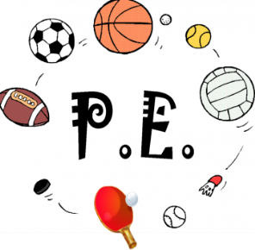
Numeracy: Maths factor modules  Login to Maths Factor to complete your modules.  Continue with your times table games | Thursday 28th May  28.05.20  Daily overview  Have fun! |  | Literacy – sight words (P1), reading (all)  Reading  Each week we will allocate a number of books to do throughout the week.  Please just do them as and when you can. There is no expectation to do them all on a Thursday when they are set.  There looks like a lot on the sheet but most of the tasks are quick and talking based.  USE YOUR ACTIVE LEARN LOGIN  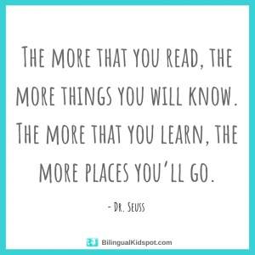
 | Please post two things every day on twitter so we know how you are getting on.

