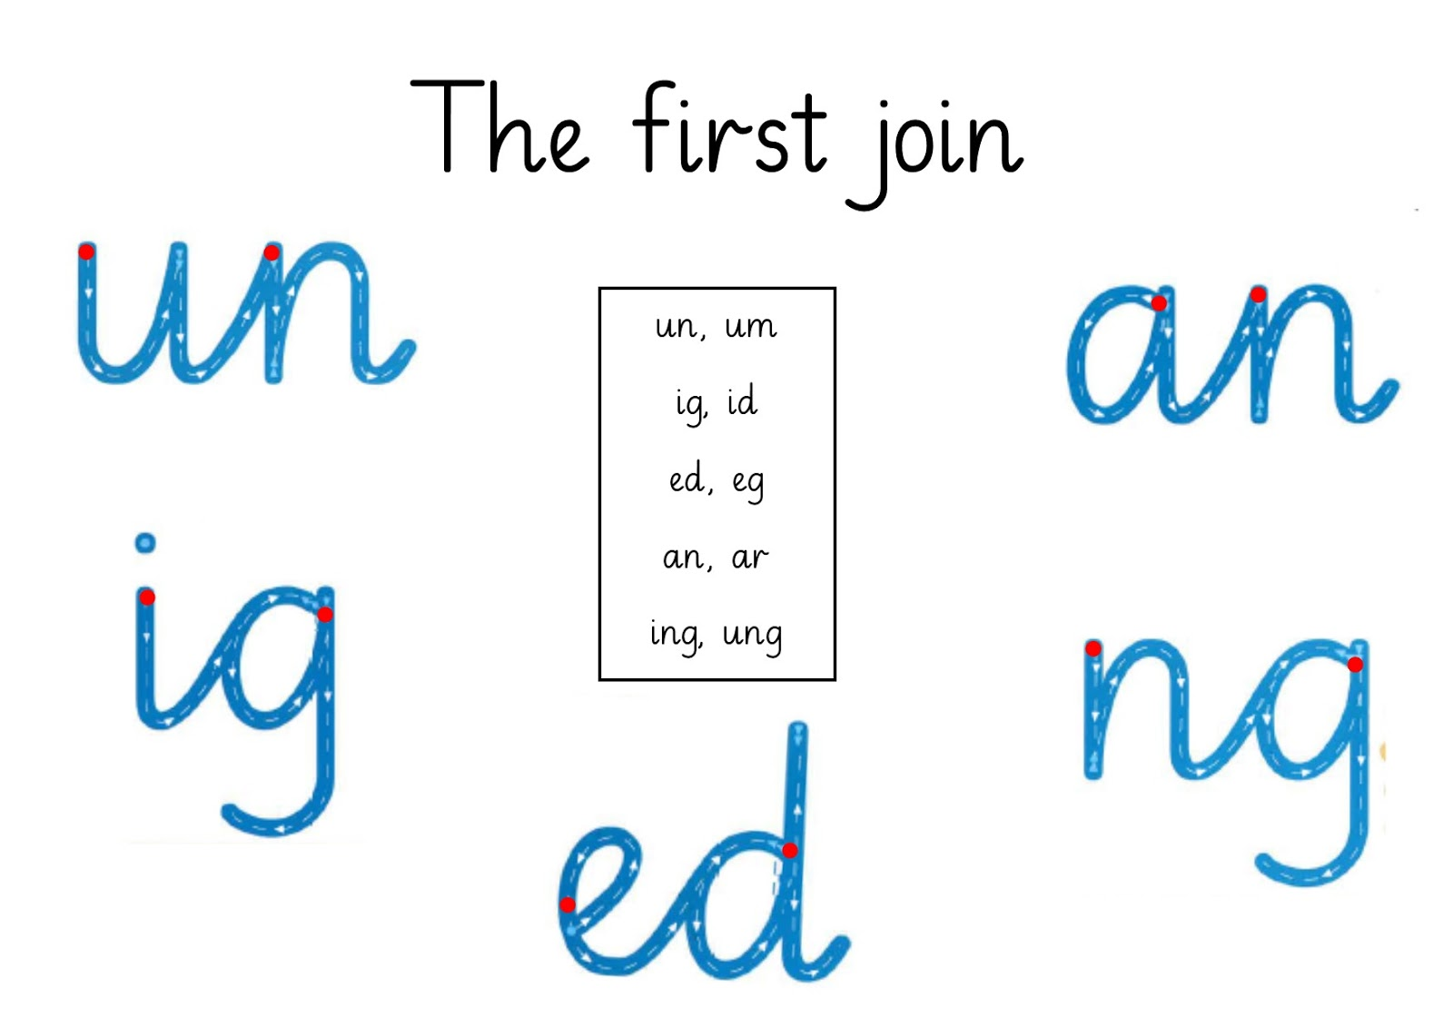

Copy the blue sounds into your jotters.

