Limes writing plan – Friday 15th May 2020 complete in your literacy jotter.
LI – I am learning how to write instructions.  SC – I can write four numbered instructions explaining how to make some toast. |  | Go and make a slice of toast (or two) together. Ask your child to talk you through what they are doing starting each sentence with a bossy verb. You can use the ones in the wordbank.  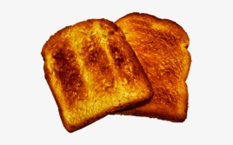 |  |  | Step 1: Date and title  Write the long date on the top line and title on the second line and underline.  Friday 15th May  How to make some toast.
WORDBANK – bossy verbs
Put Get
Spread Sit down
Eat
Step 2: Draw a picture plan in your jotter.  (split the picture area into four)  Draw four pictures to show the process of making some toast. For example  - Put the bread in the toaster.  - Put it on the plate.  - Spread on your toppings.  - Cut in half and eat. | Step 3: Talk through the steps.  It’s ok if they want to add more detail.  Use the wordbank words as sentence starters. |  | Step 4: Write what you need  Ask them what they need in each picture and ask them to write it in the box as a label.  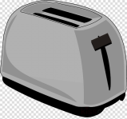 bread  toaster  Add a materials list to your instructions today.  Write Materials as a heading and list all the things you need with a bullet point  Materials | Step 5: Write your instructions  Write Steps as a heading  Start each instruction with a number.  Use the wordbank words as sentence starters. Write them on a piece of paper to copy. They should sound out the other words themselves or use their sight word tins.  REMEMBER  - CAPITAL at the start of each sentence  - FULLSTOP at the end of each sentence  - FINGER SPACES between each word
FOR PARENTS  We do emergent writing. Your child will not be able to spell everything correctly and that is ok.  Just encourage them to sound out the words they want to write or use the wordbank.  Focus them on using CAPITAL at the start of each sentence, FULLSTOP at the end of each sentence and FINGER SPACES between words. |  | Writing Example (for structure only)  See below |  |  | Writing structure  - Title  - Materials  - Steps

How to make some toast.
Materials (put them in the order they will use them)
- Bread
- Toaster
- Plate
- Knife
- Butter and peanut butter. (You can choose your own toppings)
Steps
- Put the bread in the toaster.
- Put it on the plate.
- Spread on your toppings.
- Cut in half and eat.

