Safety  Over the next few weeks we are going to look at lots of ways to keep ourselves safe.  This week we are looking at  Substance safety: Drugs and medicines: Activity 2  HWB  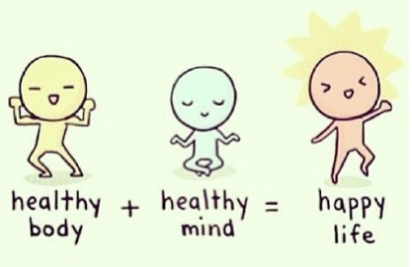 |  |  | Join in with Joe Wicks Daily workout  Live at 9am or see it on youtube later.  https://www.youtube.com/channel/UCAxW1XT0iEJo0TYlRfn6rYQ  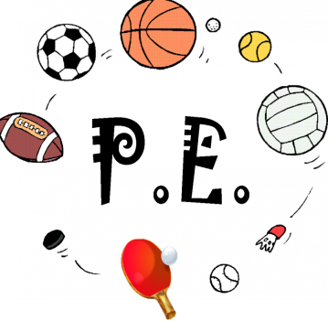
Friday Joke (a very tall toothbrush)  Post your answers in the comments on the riddles tweet.  Joke – What did the science jotter say to the numeracy jotter? | Friday 15th May  15.05.20  Daily Overview  Your activities for today.  Have fun! |  |  | Literacy – procedure writing  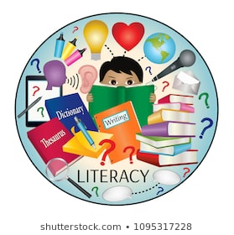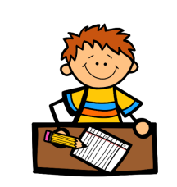  See writing plan.
 | Finish off Friday
Have a great weekend!! |  | 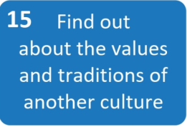  Meaningful May From  Action for Happiness  Why not find out for your project topic country? |  |  | Help out at home  Bin day!  Help by emptying one of the bins in the house or go crazy and do all the bins!

