Jeffers Reading: Thursday 14th – Wednesday 20th May
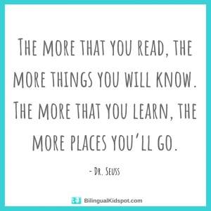
All these books are on active learn. Login to access your area.
https://www.activelearnprimary.co.uk/login?c=0
You will need – username, password and school code.

TYPE OF BOOK | TITLE | ACTIVITIES
Phonics | Pandas | - Read through front page.  - Read the book  - Back of book activities  - Bug Time!
Guided | Senses | - Read through front page.  - Read the book – using the Guided Reading sheet: session 1  - Back of book activities  - Fact file  - Try it!  - Bug Time! – look out for the bug face.  Follow up worksheet – complete in jotter.
Independent | Shaun the Sheep: Are you my Mum? | - Read through front page.  - Read the book  - Back of book activities  - How many?  - Make it!  - Bug Time! – look out for the bug face.

