This week we are going to make our own version of ‘La Gerbe’ (The Sheaf ) 1953 | LI: I am learning how to make art like Henri Matisse.  SC: I can create my own version of La Gerbe using my own colour scheme. |  | MY NEW ART WORD  LAYOUT  The way that the parts of the picture are arranged or laid out.
WATCH IT  These two stories are about Matisse’s life. Can you you remember some facts about him and his life?  https://www.youtube.com/watch?v=Uh09gdPq2M8  https://www.youtube.com/watch?v=Mghdpsysi3c | Lesson 3  cut outs |  | 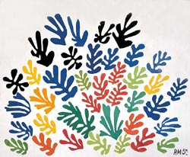
Step 1: colours  - Choose four or five colours. Haven’t got coloured paper –paint some, or use magazine pages or cardboard boxes from the recycling. | What is a sheaf?  - A sheaf is a bundle of wheat.  - Use the wheat shape to inspire your shapes. |  | Step 2: cut out and glue.  - Cut out your wheat shapes and arrange them on the white paper background.  - Play with the layout before you stick the shapes down.  - When you are happy stick them down.

La Gerbe
(The Sheaf)
Henri Matisse
1953

