Music  See the plans set by Mrs Keenan. |  | Join in with Joe Wicks Daily workout  Live at 9am or see it on youtube later.  https://www.youtube.com/channel/UCAxW1XT0iEJo0TYlRfn6rYQ
Numeracy  See your group plan.  Continue with work from Thursday last week. | Wednesday 13th May  13.05.20  Daily Timetable  Here are your activities for today.  Have fun! |  | Literacy – Sight words  See sight word sheet for your group.
 | Please post two things every day on twitter so we know how you are getting on.
Art – Henri Matisse: Lesson 3  See art learning grid  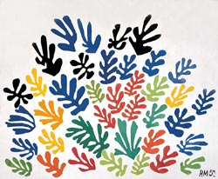 | Meaningful May  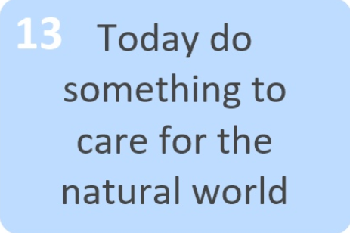 |  | Help out at home  Help out with cooking today. Maybe you could peel the tatties or butter some bread?

