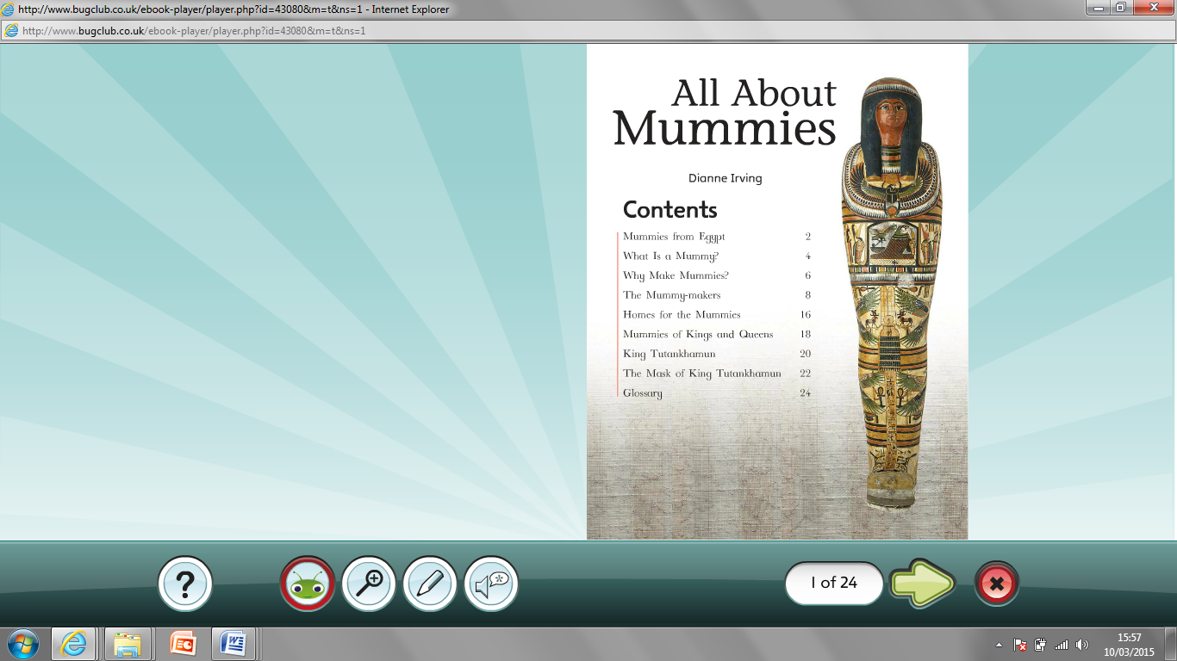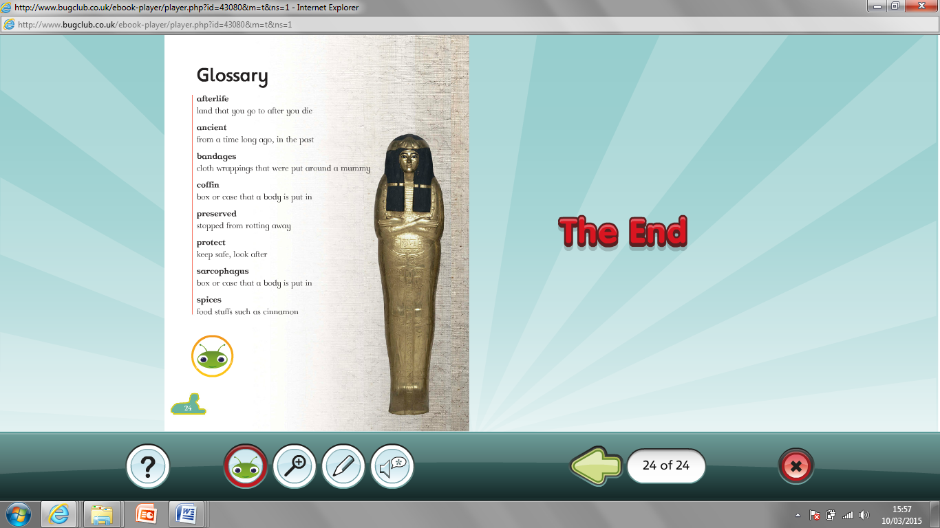

1. Which page tells me what a mummy is?
2. Which page tells me about King Tutankhamun?
3. Which page is the glossary on?
4. Where can I find out about homes for the mummies?
5. Where can I read about mummies from Egypt?
6. Where is information on the mummies of kings and queens?
7. What are bandages?
8. What does protect mean?
9. What is the definition of spices?
10. What is a coffin?
11. Which page tells me what a mummy is?
12. Which page tells me about King Tutankhamun?
13. Which page is the glossary on?
14. Where can I find out about homes for the mummies?
15. Where can I read about mummies from Egypt?
16. Where is information on the mummies of kings and queens?
17. What are bandages?
18. What does protect mean?
19. What is the definition of spices?
20. What is a coffin?