Safety  Over the next few weeks we are going to look at lots of ways to keep ourselves safe.  This week we are looking at  online safety: 5-7’s lesson 3.  HWB  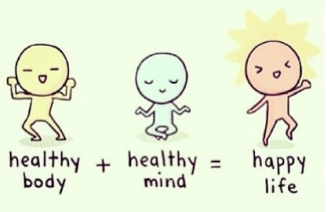 |  | Join in with Joe Wicks Daily workout  Live at 9am or see it on youtube later.  https://www.youtube.com/channel/UCAxW1XT0iEJo0TYlRfn6rYQ  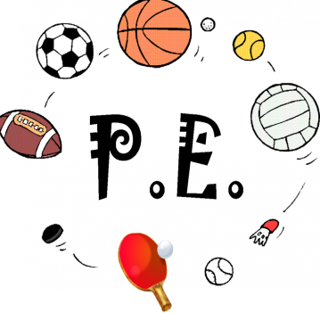
Friday Joke (last week’s answer – edam. It is the word MADE spelt backwards)  Post your answers in the comments on the riddles tweet.  Joke – What do you get if you cross a giraffe with a hedgehog? | Friday 8th May  08.05.20  Daily Overview  Your activities for today.  Have fun! |  |  | Literacy – procedure writing  See writing plan.
 | Finish off Friday
Have a great weekend!! |  |  | Meaningful May  Set yourself a kindness mission. Give your time to help others.  Who will you help today? |  | Help out at home  Dust something in the house.  Don’t have a fancy duster just use a cloth.

