Digits: Counting on and back in 2’s/5’s and 10’s (Revision)
LI: I am revising how to count on and back in 2’s, 5’s and 10’s
SC: I can count on and back in 2’s/5’s and 10’s within 100.
I can sequence numbers in 2’s/5’s and 10’s
MAKE / SAY
Splat Square
https://www.topmarks.co.uk/learning-to-count/paint-the-squares
Choose the 1-100 square
Colour in the squares to show the counting patterns for counting in twos.
Colour in the squares to show the counting patterns for counting in fives.
Colour in the squares to show the counting patterns for counting in tens.
What do you notice each time? Have a go at counting out loud forwards and backwards. Can you hear the pattern as you count?
You can use this square to learn how to count forwards and back.
WATCH
Watch the bitesize videos and complete the activity sheets.
Counting in 2’s to 50.
https://www.bbc.co.uk/bitesize/articles/zhfjqp3
Counting in 5’s to 50
https://www.bbc.co.uk/bitesize/articles/zhfjqp3
Counting on in 2’s, 3’s, 5’s and 10’s
https://www.bbc.co.uk/bitesize/articles/znywjhv
PLAY
Spring maths (please use on internet explorer)
https://www.topmarks.co.uk/Flash.aspx?f=SpringNumber
Where to find it:
- Choose the egg : counting
- Sequence numbers twos (at the bottom next to the super hero)
- Sequence numbers fives
- Sequence numbers tens

SHOW ME WHAT YOU KNOW – times table checker.
Login to active learn
Click on MY STUFF to find all your learning activities.
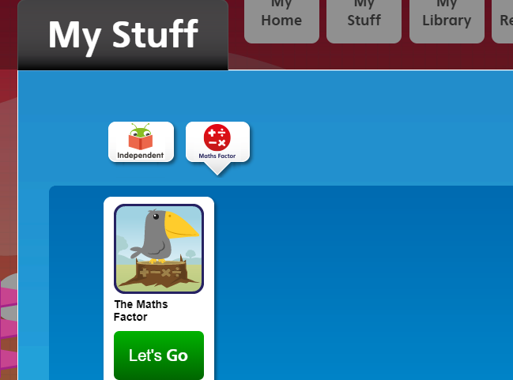
Click on Maths factor logo on the top

And then the Let’s Go button

Click on Games and fun! button the top

And then click Times Table Check

Choose explorer level. Complete the tasks.
I can see how you do.
Good luck
Mrs Short :D

