Carle Reading: Thursday 7th – Wednesday 13th May
All these books are on active learn. Login to access your area.
https://www.activelearnprimary.co.uk/login?c=0
You will need – username, password and school code.
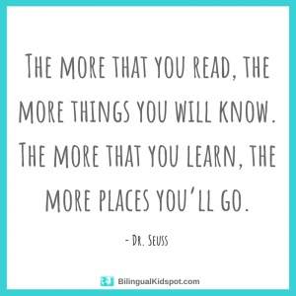

TYPE OF BOOK | TITLE | ACTIVITIES
Phonics | Chick gets lost | - Read through front page.  - Read the book  - Back of book activities
Guided | Eco Apes use rubbish | - Read through front page.  - Read the book – using the Guided Reading sheet: session 1  - Back of book activities  - Can you spot?  - Make it!  - Bug Time! – look out for the bug face.  Follow up worksheet – complete in jotter.
Independent | The Fox Twins | - Read through front page.  - Read the book  - Back of book activities  - How many?  - Draw it!  - Bug Time! – look out for the bug face.

