HWB  Safety  Over the next few weeks we are going to look at lots of ways to keep ourselves safe.  This week we are looking at  Online safety: 5- 7’s Lesson 2  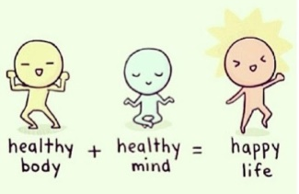 |  | 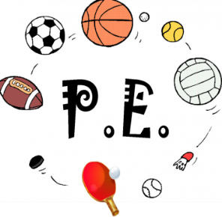  Join in with Joe Wicks Daily workout  Live at 9am or see it on youtube later.  https://www.youtube.com/channel/UCAxW1XT0iEJo0TYlRfn6rYQ
Numeracy – multiplication  See your group plan.  Complete the set tasks and then go wild playing maths games. | Thursday 7th May  07.05.20  Daily overview  Have fun! |  |  | Literacy – sight words (P1), reading (all)  Reading  Each week we will allocate a number of books to do throughout the week.  Please just do them as and when you can. There is no expectation to do them all on a Thursday when they are set.  There looks like a lot on the sheet but most of the tasks are quick and talking based.  USE YOUR ACTIVE LEARN LOGIN  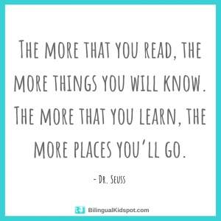
 | Please post two things every day on twitter so we know how you are getting on.
Science – My Body  Over the next few weeks we will be looking at our bodies.  P1’s will be learning about My Senses  P2/3 will be extending their learning on senses and learning about organs in the body.  See group planning sheets. |  |  | Meaningful May  From Action for Happiness  Let someone you love know how much they mean to you. |  | Help out at home  Tidy up your toy cupboard/box/  shelves/ draws

